A REPORT ON PROJECT WORK TITLED
Tourism Management System
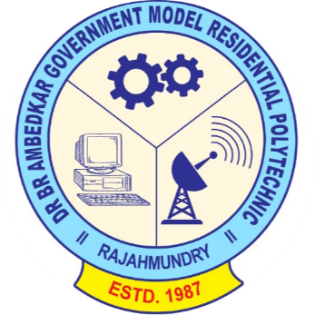
SUBMITTED BY
PROJECT ASSOCIATES
Project Team: Pin No:
B. Mourya 21072-CM-009
IN PARTIAL FULFILMENT OF REQUIREMENTS FOR THE AWARD OF
DIPLOMA IN
COMPUTER ENGINEERING

UNDER THE ESTEEMED GUIDENCE
OF
Mr. D. Srinivas, M TECH
HCMES

DEPARTMENT OF COMPUTER ENGINEERING
Dr. B R A GMR POLYTECHNIC COLLEGE
RAJAHMUNDRY-533124
2021-2024
DEPARTMENT OF COMPUTER ENGINEERING

CERTIFICATE

This is to certify that this project work entitled “Tourism Management System“ is the bonafied record work done by Mr/Ms.___________________________________ bearing the Pin No.___________________________ of the final year, along with batch mates submitted on the partial fulfilment of the requirement for the award of DIPLOMA IN COMPUTER ENGINEERING during the academic year 2021-2024.

Signature of project guide Head of the Department
(Mr. D. Srinivas)

Signature of internal guide

Signature of the External Examiner

Certificate from intern organization

This is to certify that______________________________________________(name of the intern)
Reg. No________________________________ of ______________________________(name of the
college) underwent internship in __________________________ (name of the intern organization)
from___________ to _______________

the overall performance of the intern during his/her internship is found to be __________________ (satisfactory/not satisfactory).

AUTHORIZED SIGNATORY WITH DATE AND SEAL

ACKNOWLEDGEMENT

I have been tried to my level best to complete this project taking valuable suggestions from our classmates and made it to work properly and effectively.

We thankful to our Project guide Mr. D. Srinivas, M. Tech
HCMES for her cooperation and valuable suggestions, which motivated us to complete this project.
We also extend our thanks to our Senior lecturer Mr. P. Venkata Lakshmi Narayana and Lecturers Smt. G. Sridevi, Smt. K. Bindhu, K. Padmaja, Mr. Vishnu Kumar for their valuable suggestions during the course of Project from time to time.
We also thankful to our Head of Computer Engineering and our project coordinator Mr. D. Srinivas, M. Tech HCMES for his cooperation and unflinching Devotion, which motivated us to complete this project.
We also thankful to our Respected Principal Mr. VANKA NAGESWARA RAO (M.Tech),for his kind support in successful complete on this project.
We also thankful to all teaching and non-teaching staff of Computer Engineering department who has helped us either directly or indirectly in completion of this project.

TABLE OF CONTENT

Sl.no | CONTENTS | Pg.no
1. | ABSTRACT | 5
2. | SOFTWARE REQUIREMENTS | 6
3. | INTRODUCTION | 7-12
4. | SYSTEM ANALYSIS AND FEASILIBILTY STUDY | 13-20
5. | SRS & DESIGN | 21-27
6. | SOFTWARE INSTALLATION | 27-29
6. | SOURCE CODE AND TESTING | 29-45
7. | USER MANUAL | 45-47
8. | OUTPUT SCREENS AND BIBLIOGRAPHY | 47-59

ABSTRACT
The Tourism Management System (TMS) project is a comprehensive solution designed to streamline and enhance the efficiency of tourism-related operations. This system aims to automate various tasks involved in tourism management, including tour package management, customer registration, booking, and raise ticket. By leveraging technology, the TMS facilitates easy access to information, improves resource utilization, and reduces manual efforts. Features such as a user-friendly interface and real-time data updates contribute to an enriched user experience. The implementation of the Tourism Management System not only simplifies administrative processes but also enhances the overall organization of tourism services, ensuring a seamless and organized environment for both service providers and customers.
Existing System:
The existing system for Tourism Management typically involves manual and paper-based processes. In a traditional tourism setup, tour operators manually manage tour packages, maintain paper records of customer information, and handle booking transactions manually. Customer registration and booking are also paper-based, requiring manual entry and updates in records. This manual system can be time-consuming, prone to errors, and lacks real-time accessibility to information. Additionally, tracking the availability of tour packages, managing bookings, and generating reports are cumbersome tasks in the absence of an automated system. The existing system may face challenges in terms of scalability and data accuracy as the volume of tourism services and customers increases. Transitioning to a digital Tourism Management System can address these limitations and provide a more efficient and user-friendly solution.
Proposed System:
The proposed Tourism Management System (TMS) aims to revolutionize traditional tourism operations by introducing a comprehensive digital solution. This system will be a centralized, web-based platform that automates key tourism functions, offering a user-friendly interface for both service providers and customers. The proposed system will include features such as automated tour package management, customer registration, and real-time updates on package availability. The system will facilitate online registration and provide secure login credentials for customers to access their accounts, make bookings.
SOFTWARE REQUIREMENTS

SOFTWARE SPECIFICATION:

OS : MS WINDOWS 11
Front End : HTML, CSS, BOOTSTRAP, JAVASCRIPT
Back End : Python ,Django Framework
Database : Django Database
Platform : Visual Studio Code
Hardware SPECIFICATION :

Processor : AMD Ryzen 5 5500U with Radeon Graphics 2.10 GHz
RAM : 8.0 GB RAM
Hard Disk : 512 GB SSD
Monitor : Standard color monitor
Keyboard : Standard keyboard
Mouse : Standard mouse

WEB BROWSER :
CHROME, Microsoft Edge (OR) ANY BROWSER

INTRODUCTION

The Tourism Management System (TMS) is a comprehensive software solution designed to revolutionize the way tourism services operate and manage their resources. This project aims to address the challenges and limitations of traditional tourism systems by introducing a digital platform that automates key processes, enhances user experience, and provides efficient tools for service providers. In today's fast-paced digital environment, the need for a streamlined and technology-driven approach to tourism management is imperative.

The TMS project focuses on creating a centralized system that facilitates the automation of tasks such as tour package management, customer registration, and booking processes. This system aims to replace manual, paper-based methods with a secure and efficient digital alternative. By leveraging modern database management technologies, the TMS will enable service providers to maintain a real-time catalog of available resources, monitor customer activity, and generate insightful reports for informed decision-making.

Key features of the proposed Tourism Management System include a user-friendly interface for both service providers and customers, online registration for tours.

This project documentation will provide an in-depth exploration of the TMS, covering its architecture, functionalities, system requirements, and the benefits it offers to both service providers and customers. Through this project, we aim to contribute to the modernization of tourism management practices, ensuring that tourism services remain dynamic, accessible, and responsive to the evolving needs of their customers and the industry.

HTML:
Hypertext Markup Language (HTML) is the standard markup language for creating web pages and web applications. With Cascading Style Sheets (CSS), and JavaScript, it forms a triad of cornerstone technologies for the World Wide Web. Web browsers receive HTML documents from a web server or from local storage and render them into multimedia web pages.
HTML describes the structure of a web page semantically and originally included cues for the appearance of the document.

HTML, or HyperText Markup Language, is the standard markup language used to create and design content on the World Wide Web. It serves as the backbone of web pages, defining the structure and layout of documents by using a system of tags and attributes. HTML enables the organization of text, images, links, and other multimedia elements into a coherent and visually appealing format. The language is essential for building the framework of websites, allowing content to be displayed consistently across various browsers. HTML documents are primarily text files that incorporate elements such as headings, paragraphs, lists, and multimedia embeds. The versatility of HTML lies in its ability to link resources, define text semantics, and support the integration of cascading style sheets (CSS) and scripting languages like JavaScript, contributing to the interactive and dynamic nature of modern web pages. As a fundamental technology in web development, HTML provides the foundation for creating an interconnected and user-friendly online experience.
CSS:
Cascading Style Sheets (CSS) is a crucial component of web development, complementing HTML by providing a mechanism to style and format the visual presentation of web pages. CSS allows developers to define the appearance of HTML elements, specifying attributes like color, layout, font, and spacing. It operates on a cascading principle, where styles can be inherited or overridden based on specificity and order of declaration. This separation of content and presentation enhances the maintainability and flexibility of web designs. CSS promotes consistency by enabling the application of styles across multiple pages, ensuring a cohesive look and feel for a website. The language supports responsive design, facilitating the adaptation of layouts to different screen sizes and devices. Additionally, CSS3, the latest version, introduces advanced features such as animations, transitions, and flexible box layouts, enhancing the capacity for creating visually engaging and interactive web interfaces. In summary, CSS plays a pivotal role in shaping the visual aesthetics and responsiveness of modern websites, contributing to a seamless and visually appealing user experience. Seperation of formatting and content makes it possible to present the same markup page in different styles for different rendering methods, such as on-screen, in print, by voice (via speech-based browser or screen the one the author specified.
Changes to the graphic design of a document (or hundreds of documents) can be applied quickly and easily, by editing a few lines in the CSS file they use, rather than by changing markup in the documents.
The CSS specification describes a priority scheme to determine which style rules apply if more than one rule matches against a particular element. In this so-called cascade, priorities (or weights) are calculated and assigned to rules, so that the results are predictable.

BOOTSTRAP:
Bootstrap is a free and open-source framework that makes web development easier. It's primarily focused on the front-end side of websites, meaning the visual elements that users interact with. Bootstrap utilizes HTML, CSS, and optionally JavaScript to deliver pre-built components and styles.
There are several advantages to using Bootstrap:
Responsiveness: One of its core strengths is responsiveness. Websites built with Bootstrap adapt to different screen sizes, ensuring a smooth user experience on desktops, tablets, and mobile devices. This has become essential as more and more browsing is done on phones.
Faster Development: Bootstrap provides a large collection of pre-designed components like buttons, forms, navigation bars, and more. This eliminates the need to code these elements from scratch, saving developers significant time and effort.
Ease of Use: Bootstrap is known for its beginner-friendly approach. With a basic understanding of HTML, CSS, and JavaScript, you can start creating websites with Bootstrap.
Design Flexibility: While Bootstrap offers a wide range of components, it does have a particular design aesthetic. If you need a highly customized website design, Bootstrap might not be the best choice.
Learning Curve: There's still a learning curve involved in using Bootstrap effectively. You'll need to understand how to use its components and customize them to fit your specific needs.
JAVASCRIPT:
JavaScript is a light-weight object-oriented programming language which is used by several websites for scripting the webpages. It is an interpreted, full-fledged programming language that enables dynamic interactivity on websites when applied to an HTML document. It was introduced in the year 1995 for adding programs to the webpages in the Netscape Navigator browser. Since then, it has been adopted by all other graphical web browsers. With JavaScript, users can build modern web applications to interact directly without reloading the page every time. The traditional website uses js to provide several forms of interactivity and simplicity.
Although, JavaScript has no connectivity with Java programming language. The name was suggested and provided in the times when Java was gaining popularity in the market. In addition to web browsers, databases such as CouchDB and MongoDB uses JavaScript as their scripting and query language.
There are following features of JavaScript:
- All popular web browsers support JavaScript as they provide built-in execution environments.
- JavaScript follows the syntax and structure of the C programming language. Thus, it is a structured programming language.
- JavaScript is a weakly typed language, where certain types are implicitly cast (depending on the operation).
- JavaScript is an object-oriented programming language that uses prototypes rather than using classes for inheritance.
- It is a light-weighted and interpreted language.
- It is a case-sensitive language.
- JavaScript is supportable in several operating systems including, Windows, macOS, etc.
- It provides good control to the users over the web browsers.
PYTHON:
Python is a widely used programming language that offers several unique features and advantages compared to languages like Java and C++. Our Python tutorial thoroughly explains Python basics and advanced concepts, starting with installation, conditional statements, loops, built-in data structures, Object-Oriented Programming, Generators, Exception Handling, Python RegEx, and many other concepts. This tutorial is designed for beginners and working professionals.
In the late 1980s, Guido van Rossum dreamed of developing Python. The first version of Python 0.9.0 was released in 1991. Since its release, Python started gaining popularity. According to reports, Python is now the most popular programming language among developers because of its high demands in the tech realm.
- Easy to use and Read - Python's syntax is clear and easy to read, making it an ideal language for both beginners and experienced programmers. This simplicity can lead to faster development and reduce the chances of errors.
- Dynamically Typed - The data types of variables are determined during run-time. We do not need to specify the data type of a variable during writing codes.
- High-level - High-level language means human readable code.
- Compiled and Interpreted - Python code first gets compiled into bytecode, and then interpreted line by line. When we download the Python in our system form org we download the default implement of Python known as CPython. CPython is considered to be Complied and Interpreted both.
- Purely Object-Oriented - It refers to everything as an object, including numbers and strings.
- Open Source - Python is an open-source, cost-free programming language. It is utilized in several sectors and disciplines as a result.
DJANGO:
Django is a high-level Python web framework that encourages rapid development and clean, pragmatic design. It's named after the famous jazz guitarist Django Reinhardt. Developed in 2003 by Adrian Holovaty and Simon Willison while working at the Lawrence Journal-World newspaper, Django was released as an open-source project in 2005 under the BSD license. Since then, it has grown immensely in popularity and has become one of the most widely used web frameworks for building dynamic web applications.
At its core, Django follows the "Don't Repeat Yourself" (DRY) principle, aiming to minimize redundancy and promote reusability of code. It provides a set of tools and utilities that streamline the development process, allowing developers to focus on writing their application's business logic rather than dealing with low-level details of web development.
One of the key features of Django is its powerful Object-Relational Mapping (ORM) system, which abstracts away the complexities of database interaction. Developers can define their data models using Python classes, and Django automatically handles the creation, querying, and manipulation of database tables. This makes working with databases in Django incredibly straightforward and eliminates much of the boilerplate code typically associated with database-driven applications.
Django also includes a built-in admin interface, which can be automatically generated based on the data models defined in the application. This admin interface provides a convenient way to manage site content, user accounts, and other administrative tasks without having to write custom administrative interfaces from scratch.
Furthermore, Django comes with a powerful URL routing system, which maps URLs to view functions or classes responsible for handling incoming requests. This makes it easy to organize the codebase and create clean, modular applications.
Additionally, Django includes a robust authentication and authorization system, which makes it easy to add user authentication, permissions, and access control to web applications. It also provides built-in support for common web development tasks such as form handling, session management, caching, and internationalization.
Django's architecture is designed to promote best practices in web development, including separation of concerns, scalability, and security. It encourages the use of reusable components and follows the "batteries-included" philosophy, providing developers with everything they need to build a fully featured web application out of the box.

System Analysis:
System analysis for the Tourism Management System (TMS) involves a comprehensive examination of the current tourism operations, desired functionalities, requirements, and constraints of the proposed system. This phase begins with a thorough study of the existing tourism management processes, identifying inefficiencies and challenges associated with manual procedures. Through interviews with tourism industry professionals, stakeholders, and potential users, the specific needs and expectations for the TMS are gathered.
Functional requirements are defined, encompassing various aspects of tourism management such as tour planning, booking, reservation management, itinerary customization, and payment processing. Non-functional requirements, including system performance, security, usability, and scalability, are also identified and documented to ensure the effectiveness and reliability of the system.
During system analysis, data models are developed to represent the relationships between different entities within the tourism ecosystem, such as tourists, destinations, accommodations, transportation services, and tour packages. Use cases are outlined to understand the interactions between users and the system, ensuring that all necessary functionalities are considered to facilitate a seamless user experience.
Additionally, the analysis involves a feasibility study to evaluate the economic, technical, and operational viability of implementing the TMS. This includes assessing the potential return on investment, technical capabilities required for development and maintenance, and the impact of the system on existing tourism operations.
System analysis for the TMS also considers potential challenges such as data integration with external tourism services, regulatory compliance, and user training needs. The goal is to create a detailed and accurate representation of the system requirements that will serve as the foundation for the subsequent phases of system design and implementation.
Through a systematic approach to analysis, the TMS project documentation will provide a clear roadmap for development, ensuring that the final system meets the needs of tourism industry stakeholders, enhances operational efficiency, and improves the overall tourist experience.
Feasibility Study:
The feasibility study for the Tourism Management System (TMS) is a crucial phase in the project, aimed at evaluating the viability and potential success of implementing the proposed system within the tourism industry. It comprises several key aspects:
Economic Feasibility:
The economic feasibility assesses the financial aspects of the TMS project. This involves analyzing the costs associated with development, implementation, and maintenance of the system against the expected benefits. A detailed cost-benefit analysis is conducted to determine the return on investment and the long-term economic sustainability of the TMS. Factors such as potential revenue generation, cost savings, and competitive advantages offered by the TMS are considered.
Technical Feasibility:
The technical feasibility examines the technological infrastructure required for the TMS. It evaluates the compatibility of the system with existing technology and hardware within the tourism industry. This includes assessing the availability of necessary technology and expertise, as well as any potential challenges in system integration or data migration. The scalability and adaptability of the chosen technology to accommodate future growth and changes in the tourism environment are also assessed.
Operational Feasibility:
Operational feasibility evaluates how well the TMS aligns with the operational processes of tourism businesses and organizations. It considers the impact on day-to-day activities, user acceptance, and the overall effectiveness of the system in meeting the goals of the tourism industry. This involves analyzing the willingness of tourism professionals to adapt to the new system and identifying any potential resistance to change. User training needs and support requirements are also assessed to ensure a smooth transition to the TMS.
In summary, the feasibility study for the TMS encompasses economic, technical, and operational aspects, providing a comprehensive assessment of the project's viability within the tourism industry. The findings from this study will inform decision-makers, ensuring that the implementation of the TMS is not only technically and economically feasible but also aligns seamlessly with the operational dynamics of the tourism sector, ultimately contributing to the success of the project.
Technical Feasibility:
The technical feasibility of a Tourism Management System (TMS) involves assessing whether the proposed system can be successfully developed, implemented, and integrated within the existing technological infrastructure of the tourism industry. It focuses on evaluating the technical requirements, capabilities, and constraints of the system to ensure its compatibility, scalability, and reliability. Here are some key considerations for evaluating the technical feasibility of a TMS:
Technology Assessment:
Evaluate the technological requirements of the TMS, including software, hardware, networking, and database management systems.
Determine whether the required technology is readily available and accessible within the tourism industry, or if new investments or upgrades are needed. Assess the compatibility of the TMS with existing systems, applications, and platforms used by tourism businesses, such as reservation systems, CRM software, and online booking platforms.
System Integration:
Identify the integration points and interfaces between the TMS and other external systems or services used within the tourism ecosystem.
Evaluate the feasibility of integrating the TMS with third-party APIs, databases, payment gateways, mapping services, and other relevant technologies. Ensure seamless data exchange and interoperability between the TMS and external systems to facilitate efficient information flow and process automation.
Data Management and Security:
Define the data requirements and data models for the TMS, including the types of data to be collected, stored, processed, and analyzed.
Implement robust data management practices, such as data normalization, indexing, and backup procedures, to ensure data integrity, reliability, and availability. Address data security concerns by implementing encryption, access controls, authentication mechanisms, and audit trails to protect sensitive information from unauthorized access, manipulation, or breaches.
Scalability and Performance:
Assess the scalability of the TMS to handle varying levels of workload, user traffic, and data volume, especially during peak tourism seasons or promotional campaigns.
Conduct performance testing and optimization to ensure that the TMS meets performance objectives, such as response times, throughput, and system availability. Plan for future scalability by designing the TMS architecture to support growth, expansion, and evolving business needs without compromising performance or reliability.
Technical Expertise and Resources:
Evaluate the availability of skilled technical personnel, including developers, engineers, and IT professionals, to design, develop, deploy, and maintain the TMS.
Identify any gaps in technical expertise or resource constraints that may impact the successful implementation of the TMS, and develop strategies to address them, such as training programs, outsourcing arrangements, or partnerships with technology vendors.
By addressing these technical feasibility considerations, stakeholders can assess the feasibility and readiness of implementing a Tourism Management System within the tourism industry. This evaluation helps ensure that the TMS leverages appropriate technologies, adheres to industry standards, and meets the technical requirements and expectations of users and stakeholders, ultimately contributing to its successful adoption and utilization within the tourism ecosystem.
Operational Feasibility:
Operational feasibility assesses how well a Tourism Management System (TMS) aligns with the operational processes and dynamics of the tourism industry. It focuses on evaluating whether the system can be effectively implemented and integrated into existing workflows, as well as its overall impact on day-to-day operations. Here are some key considerations for evaluating the operational feasibility of a TMS:
Alignment with Operational Processes:
Analyze the current operational processes within the tourism industry, including tour planning, booking, reservation management, customer service, and marketing. Determine how the TMS can streamline and improve these processes, making them more efficient, cost-effective, and customer-friendly.
Identify any potential gaps or inefficiencies in current operations that the TMS can address, such as manual data entry, communication bottlenecks, or inconsistent service delivery.
User Acceptance and Adoption:
Assess the willingness of tourism industry professionals, including tour operators, travel agents, and hospitality staff, to adopt and utilize the TMS. Conduct surveys, interviews, or focus groups to gauge user attitudes, perceptions, and concerns regarding the implementation of the TMS.
Provide comprehensive training and support programs to ensure that users are equipped with the necessary skills and knowledge to effectively utilize the TMS in their daily activities.
Impact on Stakeholders:
Consider the perspectives and interests of various stakeholders, including tourism businesses, employees, customers, and regulatory authorities. Evaluate how the TMS will affect stakeholder relationships, communication channels, and decision-making processes within the tourism ecosystem.
Address any potential resistance to change or conflicts of interest among stakeholders by involving them in the planning, development, and implementation phases of the TMS project.
Scalability and Adaptability:
Assess the scalability of the TMS to accommodate growth and changes within the tourism industry, such as fluctuations in demand, new market trends, or emerging technologies.
Ensure that the TMS is flexible and adaptable enough to support diverse tourism offerings, destinations, and business models, including both large-scale enterprises and small businesses. Consider future expansion opportunities, such as international markets, niche tourism segments, or partnership collaborations, and ensure that the TMS can
By addressing these operational feasibility considerations, stakeholders can assess the suitability of a Tourism Management System for their specific needs and requirements. This evaluation helps ensure that the TMS not only enhances operational efficiency and effectiveness but also fosters positive user experiences, stakeholder engagement, and long-term success within the tourism industry.
Economic Feasibility:
The economic feasibility of a Tourism Management System (TMS) is a crucial aspect that assesses the financial viability and potential return on investment (ROI) of implementing such a system within the tourism industry. It involves evaluating various financial factors to determine whether the benefits of the TMS outweigh the costs associated with its development, implementation, and maintenance. Here are some key considerations for assessing the economic feasibility of a TMS:
Cost Analysis:
Development Costs: Evaluate the expenses associated with designing, developing, and customizing the TMS software. This includes costs related to hiring developers, purchasing software licenses, and acquiring necessary development tools. Implementation Costs: Estimate the costs involved in deploying the TMS within tourism businesses and organizations. This may include expenses for system integration, hardware upgrades, and employee training.
Maintenance Costs: Consider the ongoing expenses associated with maintaining and supporting the TMS. This includes costs for software updates, technical support, and infrastructure maintenance.
Benefit Analysis:
Revenue Generation: Assess the potential revenue streams that the TMS can facilitate for tourism businesses. This may include increased bookings, higher customer retention rates, and new business opportunities enabled by enhanced tourism management capabilities.
Cost Savings: Identify potential cost savings resulting from improved efficiency and automation offered by the TMS. This may include reduced administrative overhead, streamlined operations, and optimized resource utilization.
Competitive Advantages: Analyze the competitive advantages gained by tourism businesses that implement the TMS. This could include improved customer satisfaction, enhanced service offerings, and differentiation from competitors.
Return on Investment (ROI):
Conduct a comprehensive cost-benefit analysis to determine the projected ROI of the TMS over time. Compare the anticipated benefits, such as revenue growth and cost savings, against the total costs incurred throughout the lifespan of the system.
Calculate the payback period, which represents the time it takes for the accumulated benefits of the TMS to offset the initial investment. A shorter payback period indicates a quicker return on investment and higher economic feasibility.
Risk Assessment:
Identify and assess potential risks and uncertainties that may impact the economic feasibility of the TMS project. This includes factors such as market volatility, technological obsolescence, and regulatory changes.
Develop risk mitigation strategies to address potential challenges and minimize their impact on the financial outcomes of the TMS implementation.
By conducting a thorough economic feasibility analysis, tourism industry stakeholders can make informed decisions regarding the implementation of a Tourism Management System. This assessment helps ensure that the TMS not only delivers value to tourism businesses but also offers a favorable return on investment, contributing to the overall economic success and sustainability of the tourism industry.
Legal Feasibility:
Legal feasibility in the context of a project refers to the examination of potential legal issues and constraints associated with the project's development and implementation. It involves assessing whether the project complies with local, national, and international laws and regulations. This feasibility study aims to identify any legal challenges, risks, or restrictions that might impact the project's execution. Legal feasibility may include considerations such as intellectual property rights, licensing requirements, data protection laws, and any industry-specific regulations. Ensuring legal compliance is crucial to prevent legal complications, regulatory penalties, or disputes that could arise during or after the project implementation. Addressing legal aspects early in the project planning phase helps to mitigate risks and ensures that the project proceeds smoothly within the boundaries of the law.

SOFTWARE REQUIREMENT & SPECIFICATION:
The software requirements and specifications for documentation of the proposed Tourism Management System (TMS) encompass a variety of tools and platforms to ensure seamless development and management. The operating system for the development environment is specified as Microsoft Windows 11. For the front-end development, a combination of HTML, CSS, BOOTSTRAP and JAVASCRIPT is chosen to create a dynamic and responsive user interface tailored to the needs of the tourism industry. On the backend PYTHON coupled with the DJANGO framework, will handle server-side logic and facilitate efficient communication between the client and the database.
Speaking of the database, DJANGO Database is the chosen relational database management system (RDBMS), ensuring data integrity and scalability necessary for managing diverse tourism-related information. The development environment is primarily supported by Visual Studio Code, a versatile and extensible code editor that provides an efficient platform for writing, debugging, and managing code.
These software choices have been made with careful consideration of their compatibility, efficiency, and industry relevance within the tourism sector. This stack provides a robust foundation for the development of the Tourism Management System, combining modern front-end technologies with a powerful and reliable back-end infrastructure. The specified tools collectively create an environment that fosters productivity, collaboration, and ease of maintenance throughout the software development life cycle. This documentation will further detail the configuration, installation, and utilization of these software components to ensure a comprehensive and well-documented approach to the Tourism Management System project.
DESIGN
SYSTEM DESIGN:
System design is the bridge between software requirements and the implementation that satisfies those requirements. It can be defined as the process of applying various techniques and principles for the purposes of defining a device, a processor, or a system in sufficient detail to prevent its physical realization. During the preliminary design phase, the requirements are transformed into software architecture, and during the detail design phase, the main focus is on the refinement of the architectural representation that leads to algorithmic representations for software. The techniques used for this project development are structured design and integrated top-down design. Program structure is prepared which defines control hierarchy without regard to the sequence of processing and decision-making. It focuses on the processing and sequence of events, exact decision points, and repetitive operations. During design, functional independence is achieved by developing modules with a single-minded function and an aversion to excessive interactions with other modules.
System design is the process of defining the architecture, components, modules, interfaces, and data for a system to satisfy specified requirements. In the context of a Tourism Management System, the following design aspects are considered:
Architectural Design:
The architectural design of a Tourism Management System emphasizes the design of the system architecture that describes the structure, behavior, and various views of the system and its analysis. This includes defining the components and their interactions, as well as identifying any external systems or services that the TMS interfaces with.
Logical Design:
The logical design of a Tourism Management System pertains to an abstract representation of the data flows, inputs, and outputs of the system. This is often conducted via modeling, using an abstract (and sometimes graphical) model of the actual system. In the context of a TMS, logical design includes entity-relationship diagrams (ER diagrams) to represent the relationships between different entities such as tourists, destinations, accommodations, and bookings.
Physical Design: The physical design of a Tourism Management System relates to the actual input and output processes of the system. This includes defining how data is input into the system (e.g., through user interfaces or integration with external systems), how it is processed (e.g., booking processing, itinerary generation), and how it is output (e.g., displaying information to users). Physical design also encompasses requirements such as input/output requirements, storage requirements, processing requirements, system control, and backup/recovery mechanisms specific to the TMS.
By addressing these design considerations, the Tourism Management System can be effectively planned, structured, and implemented to meet the needs and requirements of the tourism industry while ensuring scalability, reliability, and maintainability.
Modules:
- Guest User
- User
- Admin
In Guest User:

- Visit the Website - the guest user can visit the website without any registration and login.

- Enquiry - the guest user can enquire how many packages are there and types in that, but he can’t book the package without registration.
In Users:

- Register - User can register himself and login to access the page and do bookings.
- Tour Booking - Users can book the tour within the packages which the admin has created.
- My tour history - users can view their tour history in a table with the booked package details.
- Raised tickets - Here, they can create new tickets by providing relevant information about their issue or request.

In Admin:

- Create packages - the admin can create packages means, the admin will add the best tour plan for the rate he is given. And he can modify the packages.
- Manage users - the admin can manage the users to activate or deactivate to login.
- Manage enquiries - the admin can view, the user has booked or canceled the package.
- Manage bookings - the admin can view how many users have booked the tickets.
Flow Charts
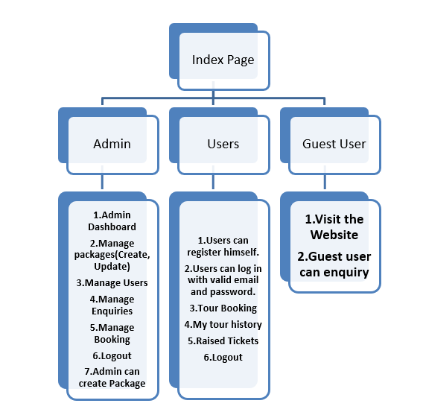
Architecture –

Use case Diagram -
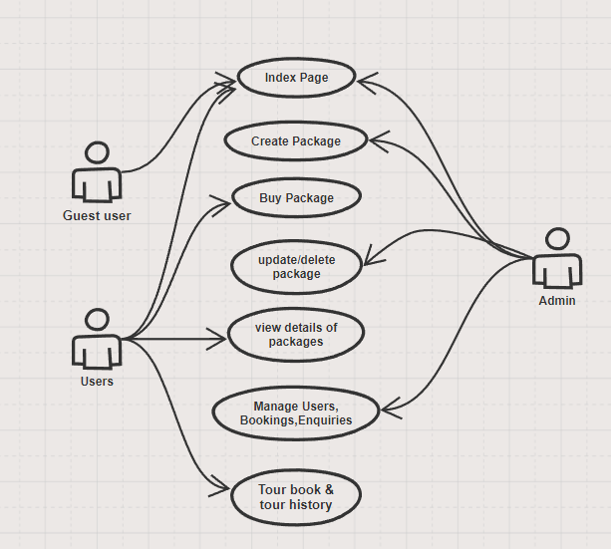

Flow

ER-Diagram -
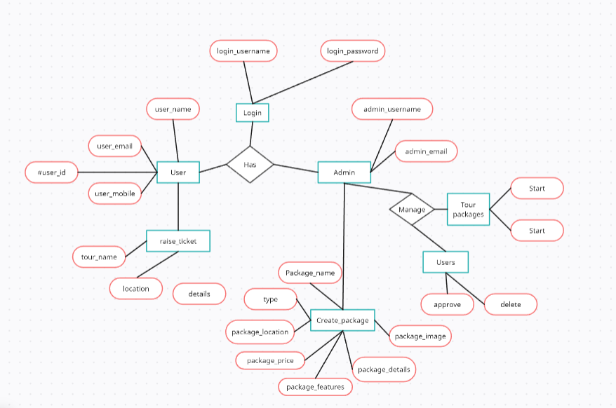
SOFTWARE INSTALLATION
Windows:
Download Django:
Step 1: Install Pip
Open the command prompt and enter the following command-
python -m pip install -U pip
Step 2: Set Virtual environment:
Setting up the virtual environment will allow you to edit the dependency which generally your system wouldn’t allow. Follow these steps to set up a virtual environment-
Step 3: Create virtual environment in Django:
We should first go the directory where we want to create the virtual environment then we type the following command to create virtual environment in Django .
python -m venv env_site
then we need to activate virtual environment in Django.
Step 4: Activate the virtual environment:
Run the activation script located in the bin directory within the virtual environment folder
For Windows:
.\env_site\Scripts\activate.ps1
Step 5: Install Django:
Install django by giving following command
pip install Django
Django Setup
Once Django is installed, we can start to create a new Django project.
Step 1: Start a new Django Project
Start a project by following command-
django-admin startproject geeks_site
Step 2: Navigate to the Project Directory
Change directory to geeks_site
cd geeks_site
Step 3: Start the server
Start the server by typing following command in cmd-
python manage.py runserver
Step 4: Verify Server Status
To check whether server is running or not go to web browser and enter http://127.0.0.1:8000/ as URL.
CODING:
Coding may refer to:
- Channel coding, in coding theory
- Line coding
- Computer programming, the process of designing, writing, testing, debugging / troubleshooting, and maintaining the source code of computer programs.
- The process of Statistical classification of information.
- Coding (social sciences), refers to an analytical process in which data, in both quantitative form (such as questionnaires results) or qualitative (such as interview transcripts) are categorised to facilitate analysis.
- Coding (therapy), a controversial therapy used to treat addictions.
- Legal coding, the process of creating summary or keyword data from a document. It is widely used in the legal profession to create a fast-search index or database of documents for use in litigation.
- A coding strand of DNA is translated into a protein product.
- Code Blue (emergency code), which is a patient in Cardiac Arrest or Respiratory Arrest.

Summary About Coding Part
- Introduction Page.
- Home Page
- About
- Tour packages
- Enquiry
- Contact us
- Admin Login, User Signup, User Signin
- Admin Dashboard
- Manage Users
- Create package
- Manage Enquiries
- Manage package
- Bookings
- User Raised tickets
- User Dashboard
- Tour packages
- My tour history
- Raise ticket
6. Backend part.
Introduction:
<section class="showcase">
<header>
<h2 class="logo">Tour's and Travel's</h2>
</header>
<video src="{% static 'assets/vd2.mp4' %}" muted loop autoplay></video>
<div class="overlay"></div>
<div class="text ">
<h2>Never Stop To </h2>
<h3>Exploring The World</h3>
<p> “Once the travel bug bites there is no known antidote,
and I know that I shall be happily infected until the end of my life.”</p>
<a href="{% url 'home' %}">View Page</a>
</div>
</section>

Home page:
{% extends "pages/master.html" %}
{% load static %}
{% block title %}
Home
{% endblock %}
{% block extra_head %}
<link rel="stylesheet" href="{% static 'css/home.css' %}">
<link href="https://cdn.jsdelivr.net/npm/bootstrap@5.0.2/dist/css/bootstrap.min.css" rel="stylesheet"
integrity="sha384-EVSTQN3/azprG1Anm3QDgpJLIm9Nao0Yz1ztcQTwFspd3yD65VohhpuuCOmLASjC" crossorigin="anonymous">
<script src="https://cdn.jsdelivr.net/npm/bootstrap@5.0.2/dist/js/bootstrap.bundle.min.js"
integrity="sha384-MrcW6ZMFYlzcLA8Nl+NtUVF0sA7MsXsP1UyJoMp4YLEuNSfAP+JcXn/tWtIaxVXM"
crossorigin="anonymous"></script>
<link rel="stylesheet" href="https://cdnjs.cloudflare.com/ajax/libs/font-awesome/6.2.0/css/all.min.css">
{% endblock %}
{% block content %}
<body style=" background-image: url('{% static "assets/nat2.png" %}');
background-size: cover;
background-repeat: no-repeat;
background-position: center;
background-attachment: fixed;">
<section>
<div class="total" >
<div class="col-12">
<div class="row1 bg1">
<div class="col-6 d-flex ms-5 ">
<a href="{% url 'admin_login' %}"><button class="butt1"><b>Admin Login</b></button></a>
</div>
<div class="col-6 d-flex justify-content-evenly text-white">
<a href="{% url 'sign_up' %}"><button class="butt2"><b>SignUp</b></button></a>
<a href="{% url 'sign_in' %}"><button class="butt2"><b>SignIn</b></button></a>
</div>
</div>
<div class="row2" style="background-image:url('{% static "assets/img7.jpeg" %}');background-size:contain;">
<div class="col-3 ">
<img class="img2" src="{% static '\assets\img9.png' %}" alt="logo">
</div>
<div class="col-9 ">
<h1 style="font-family:Monospace;text-shadow: 2px 2px 5px red;"><b><i>Tour's and Travel's</i></b></h1>
</div>
</div>
<div class="row3 bg-light ">
<div class="col-2 d-flex justify-content-around">
<a href="#"> <img class="homeimg" src="{% static '\assets\home5.png' %}" alt="home "></a>
</div>
<div class="col-10 d-flex justify-content-around">
<a href="{% url 'about' %}"><button class="butt3">About</button></a>
<a href="{% url 'tour_package' %}"><button class="butt4">Tour Packages</button></a>
<a href="{% url 'enquiry' %}"><button class="butt5">Enquiry</button></a>
<a href="{% url 'contact_us' %}"><button class="butt6">Contact Us</button></a>
</div>
</div>
<div class="row4" >
<div class="col-4">
<h1 class="text1">Top Tour's To Visit</h1>
</div>
<div class="col-8" > <br>
<div class="gallery" >
<figure class="card1">
<img src="{% static '\assets\1.jpg' %}" alt="Paris">
</figure>
<figure class="card1">
<img src="{% static '\assets\2.jpg' %}" alt="Los Angeles">
</figure>
<figure class="card1">
<img src="{% static '\assets\3.jpg' %}" alt="Ayodhya" >
</figure>
<figure class="card1">
<img src="{% static '\assets\4.jpg' %}" alt="New York" >
</figure>
<figure class="card1">
<img src="{% static '\assets\5.jpg' %}" alt="New York">
</figure>
</div>
</div>
</div>
<h1 style="text-align:center;color:white;font-family:ATC Laurel Black;font-size:45px;">Tour Packages </h1><br>
<div class="row6 container">
<div class="col-4">
<div class="card card3" style="width: 18rem;">
<img src="{% static "assets/kerala.jpg" %}" class="card-img-top" alt="">
<div class="card-body">
<h5 class="card-title">Kerala</h5>
<p class="card-text">You will have the best accommodation, You will have the best travel facility..ect</p>
<button
type="button" class="btn btn-primary" data-bs-toggle="modal" data-bs-target="#staticBackdrop">Details</button>
</div>
</div>
</div>
<div class="col-4">
<div class="card card3" style="width: 18rem;">
<img src="{% static "assets/italy.jpg" %}" class="card-img-top" alt="">
<div class="card-body">
<h5 class="card-title">Italy</h5>
<p class="card-text">You will have the best accommodation, You will have the best travel facility..ect</p>
<button
type="button" class="btn btn-primary" data-bs-toggle="modal" data-bs-target="#staticBackdrop">Details</button>
</div>
</div>
</div>
<div class="col-4">
<div class="card card3" style="width: 18rem;">
<img src="{% static "assets/charminar.jpg" %}" class="card-img-top" alt="">
<div class="card-body">
<h5 class="card-title">Hyderabad</h5>
<p class="card-text">You will have the best accommodation, You will have the best travel facility..ect</p>
<button
type="button" class="btn btn-primary" data-bs-toggle="modal" data-bs-target="#staticBackdrop">Details</button>
</div>
</div>
</div>
</div>
<a style="margin-top:-20px;margin-left:530px;" href="{% url 'tour_package' %}"><button class="btn btn-warning"><b>More packages..</b></button></a><br><br><br>
<h1 style="text-align:center;color:white;font-family:ATC Laurel Black;font-size:45px;">Services </h1><br>
<div class="row9 container">
<div class="col-4">
<div class="card card2" style="width: 18rem;">
<img src="{% static '\assets\travel.png' %}" class=" card_img" alt="">
<div class="card-body">
<h5 class="card-title">Travel</h5>
<p class="card-text">"Experience the world with unparalleled comfort and convenience through our top-rated travel services."</p>
</div>
</div>
</div>
<div class="col-4">
<div class="card card2" style="width: 18rem;">
<img src="{% static '\assets\hotel.png' %}" class=" card_img" alt="">
<div class="card-body">
<h5 class="card-title">Accommodation</h5>
<p class="card-text">
"Indulge in luxurious comfort and unforgettable experiences with our premier accommodation services."</p>
</div>
</div>
</div>
<div class="col-4">
<div class="card card2" style="width: 18rem;">
<img src="{% static '\assets\food.png' %}" class="card_img" alt="">
<div class="card-body">
<h5 class="card-title">Food</h5>
<p class="card-text">"Savor the flavors of the world with our exquisite culinary offerings, ensuring a delectable dining experience during your travels."</p>
</div>
</div>
</div>
</div>
<div class="row8">
<img src="{% static '\assets\img12.jpg' %}" alt="logo" width="1260px" height="520px">
</div>
<div class="row5 ">
<div class="col-1"></div>
<div class="col-10 "><br>
<h1 style="text-align:center;color:white;font-family:Quadrat;">About Tour's And Travel's</h1><br>
<p class="container text-light" style="font-family:Rockwell;">A tours and travels website serves as a virtual gateway to the world of travel, offering a platform where travelers can explore destinations, plan their trips, and make bookings conveniently. <br>
Discover the world at your fingertips with our comprehensive platform designed to cater to al l your travel needs. Whether you're seeking relaxation, adventure, or cultural immersion, we're here to make your travel dreams a reality.</p><a href="{% url 'about' %}"><button class="btn btn-warning"><b>Read more..</b></button></a>
</div>
<div class="col-1"></div>
</div>
<div class="row7">
<footer>
<div class="container">
<div class="footer-col">
<h2>TOUR'S AND TRAVEL'S</h2>
<p class="footer-para"> “Once the travel bug bites there is no known antidote,
and I know that I shall be happily infected until the end of my life.”
</p>
<img style="width:150px;height:150px;" src="{% static '\assets\img10.png' %}" alt="logo">
</div>
<div class="footer-col">
<h3 class="text-office">
Office
<div class="underline"><span></span></div>
</h3>
<p>Lion's club opp</p>
<p>Facor route</p>
<p>Garividi , Andhra Pradesh</p>
<p class="email">toursandtravels@gmail.com</p>
<p class="phone">+91 2233445566</p>
</div>
<div class="footer-col">
<h3>
Menu
<div class="underline"><span></span></div>
</h3>
<ul>
<li><a class="btn text-white a1" href="#">Home</a></li>
<li><a class="btn text-white a1" href="{% url 'about' %}">About</a></li>
<li><a class="btn text-white a1" href="{% url 'contact_us' %}">Contact Us</a></li>
<li><a class="btn text-white a1" href="{% url 'enquiry' %}">Enquiry</a></li>
<li><a class="btn text-white a1" href="{% url 'tour_package' %}">Packages</a></li>
</ul>
</div>
</div>
</footer>
</div>
</div>
</div>
</section>
<div class="modal fade" id="staticBackdrop" data-bs-backdrop="static" data-bs-keyboard="false" tabindex="-1" aria-labelledby="staticBackdropLabel" aria-hidden="true">
<div class="modal-dialog">
<div class="modal-content">
<div class="modal-header">
<h5 class="modal-title" id="staticBackdropLabel">To Watch Details</h5>
<button type="button" class="btn-close" data-bs-dismiss="modal" aria-label="Close"></button>
</div>
<div class="modal-body">
You have to must Login
</div>
<div class="modal-footer">
<a href="{% url 'sign_up' %}"><button class="btn btn-info"><b>SignUp</b></button></a>
<button type="button" class="btn btn-secondary" data-bs-dismiss="modal">Close</button>
</div>
</div>
</div>
</div>
</body>
{% endblock %}

Create package-
{% extends "pages/master.html" %}
{% load static %}
{% block title %}
Create Packages
{% endblock %}
{% block extra_head %}
<link rel="stylesheet" href="{% static 'css/create_package.css' %}">
<link href="https://cdn.jsdelivr.net/npm/bootstrap@5.0.2/dist/css/bootstrap.min.css" rel="stylesheet"
integrity="sha384-EVSTQN3/azprG1Anm3QDgpJLIm9Nao0Yz1ztcQTwFspd3yD65VohhpuuCOmLASjC" crossorigin="anonymous">
<script src="https://cdn.jsdelivr.net/npm/bootstrap@5.0.2/dist/js/bootstrap.bundle.min.js"
integrity="sha384-MrcW6ZMFYlzcLA8Nl+NtUVF0sA7MsXsP1UyJoMp4YLEuNSfAP+JcXn/tWtIaxVXM"
crossorigin="anonymous"></script>
<link rel="stylesheet" href="https://cdnjs.cloudflare.com/ajax/libs/font-awesome/6.2.0/css/all.min.css">
{% endblock %}
{% block content %}
<body style=" background-image: url('{% static "assets/img11.jpg" %}');
background-size: cover;
background-repeat: no-repeat;
background-position: center;
background-attachment: fixed;">
<section class="sec1">
<h1>Create Package</h1>
<form action="{% url 'create_package' %}" method="POST" class='form' enctype="multipart/form-data"><br>
{% csrf_token %}
<div class="form-floating mb-3 ">
<input type="text" name="package_name" class="form-control rounded-pill border border-info" id="floatingInput" placeholder="Package Name" required>
<label for="floatingInput">Package Name</label>
</div>
<div class="form-floating mb-3">
<input type="text" name="package_type" class="form-control rounded-pill border border-info" id="floatingInput" placeholder="Package Type" required>
<label for="floatingInput">Package Type</label>
</div>
<div class="form-floating mb-3">
<input type="text" name="package_location" class="form-control rounded-pill border border-info" id="floatingInput" placeholder="Package Location" required>
<label for="floatingInput">Package Location</label>
</div>
<div class="form-floating mb-3">
<input type="number" name="package_price" class="form-control rounded-pill border border-info" id="floatingInput" placeholder="Package Price" required>
<label for="floatingInput">Package Price</label>
</div>
<div class="form-floating mb-3">
<input type="text" name="package_features" class="form-control rounded-pill border border-info" id="floatingInput" placeholder="Package Features" required>
<label for="floatingInput">Package Features</label>
</div>
<div class="form-floating">
<textarea class="form-control rounded-pill border border-info" name="package_details" placeholder="Package Details" id="floatingTextarea" required></textarea>
<label for="floatingTextarea">Package Details</label>
</div><br>
<div class="input-group mb-3">
<label class="input-group-text rounded-pill border border-info" for="inputGroupFile01">Upload</label>
<input type="file" name="package_image" class="form-control" id="inputGroupFile01" required>
</div><br>
<button class="btn btn-primary butt" type="submit">Create</button>
</form>
</section>
{% if messages %}
<script>
alert("{% for msg in messages %}{{ msg }}{% endfor %}");
</script>
{% endif %}
</body>
{% endblock %}

TESTING:
Testing is an essential phase in the development of a Tourism Management System (TMS) to guarantee its functionality, absence of bugs, and alignment with user requirements. The testing process encompasses various types of testing, each serving a specific purpose:
Unit Testing:
Objective: Validate the correctness of individual units or components within the system.
Focus: Test individual functions, methods, or procedures.
Example: Test a function that handles booking to ensure it correctly updates the database.
Integration Testing:
Objective: Ensure seamless interaction between different components/modules of the system.
Focus: Test the integration and communication between different modules.
Example: Test the flow of data between the Booking Management .
System Testing:
Objective: Verify the entire system against predefined requirements.
Focus: Test end-to-end functionalities, system behavior, and user interfaces.
Example: Test the complete process of trip booking, including itinerary creation, and confirmation.
Acceptance Testing:
Objective: Confirm that the system meets user expectations and fulfills business requirements.
Focus: Validate if the system aligns with specified use cases.
Example: Have travel agents and customers perform common booking tasks to ensure usability and functionality.

Performance Testing:
Objective: Evaluate the system's responsiveness and stability under varying conditions.
Focus: Test scalability, response times, and resource usage.
Example: Simulate a high volume of concurrent bookings to assess system performance under load.
Security Testing:
Objective: Identify and address potential vulnerabilities in the system.
Focus: Test data integrity, user authentication, and protection against security threats.
Example: Verify the robustness of user authentication mechanisms and encryption of sensitive data.
Usability Testing:
Objective: Assess the user interface and overall user experience.
Focus: Evaluate system navigation, user friendliness, and accessibility.
Example: Have representative users perform common booking tasks.
Regression Testing:
Objective: Ensure that new changes do not negatively impact existing functionalities.
Focus: Re-test previously validated functionalities after system updates or modifications.
Example: After implementing a new feature for tour customization, ensure existing functionalities remain intact.
A comprehensive testing approach, incorporating these different types of testing, ensures the reliability, functionality, and security of the Tourism Management System before its deployment for real-world use.

Backend: Views –
Admin login-
from django.shortcuts import render,redirect
from django.contrib.auth import authenticate,login,logout
from django.contrib.auth.decorators import login_required
from django.contrib import messages

def admin_login(request):
if request.method == 'POST':
username = request.POST.get('username')
password = request.POST.get('password')
user = authenticate(request, username=username, password=password)

if user is not None:
login(request, user)
request.session['superuser_email'] = user.email
print(user.email)
return redirect('admin_dashboard')
else:

messages.info(request, "User is not existed..")
return render(request, 'pages/admin_login.html')
else:

return render(request, 'pages/admin_login.html')

def admin_logout(request):
logout(request)
if 'superuser_email' in request.session:
del request.session['superuser_email']
return redirect('admin_login')

@login_required
def admin_dashboard(request):
superuser_email = request.session.get('superuser_email', None)
return render(request,'pages/admin_dashboard.html')

Create package-
from django.shortcuts import render,redirect
from tour.models import *
from django.contrib import messages

def packages(request):
return render(request,'pages/create_package.html')

def create_package(request):
if request.method == 'POST':
package_name = request.POST.get('package_name')
package_type = request.POST.get('package_type')
package_location = request.POST.get('package_location')
package_price = request.POST.get('package_price')
package_features = request.POST.get('package_features')
package_details = request.POST.get('package_details')
package_image = request.FILES.get('package_image') # Use request.FILES to get file data

package = CreatePackage(
package_name=package_name,
package_type=package_type,
package_location=package_location,
package_price=package_price,
package_features=package_features,
package_details=package_details,
package_image=package_image,
)
package.save()
messages.info(request, "Package created..")

return redirect('admin_dashboard')

Manage packages-
from django.shortcuts import render ,redirect
from tour.models import *
from django.contrib import messages

def manage_package(request):
packages = CreatePackage.objects.all()
return render(request, 'pages/manage_package.html', {'packages': packages})

def update_package(request,pk):
package = CreatePackage.objects.get(id=pk)

if request.method == 'POST':
package.package_name = request.POST.get('package_name')
package.package_type = request.POST.get('package_type')
package.package_location = request.POST.get('package_location')
package.package_price = request.POST.get('package_price')
package.package_features = request.POST.get('package_features')
package.package_details = request.POST.get('package_details')
package.package_image = request.FILES.get('package_image')
package.save()
messages.info(request, "Package is Updated...")
return redirect('admin_dashboard')

context = {
'package': package
}

return render(request, 'pages/update_package.html', context)

def delete_package(request, id):
entry = CreatePackage.objects.get(id=id)
entry.delete()
return redirect('admin_dashboard')

My tour history-
from django.shortcuts import render ,get_object_or_404, redirect
from tour.models import *
from django.contrib import messages

def history(request):
email = request.session.get('email')
user = get_object_or_404(UserRegister, email=email)
tour = Bookings.objects.filter(email=user)
context = {
'cart_items': tour
}
return render(request, 'pages/my_tourhistory.html', context)

def cancel_booking(request,booking_id):
booking = get_object_or_404(Bookings, id=booking_id)

booking.delete()

messages.success(request, 'Booking canceled successfully.')
return redirect('user_dashboard')

Enquiries-

from django.shortcuts import render ,redirect ,get_object_or_404
from tour.models import *
from django.core.mail import send_mail
from django.core.exceptions import ValidationError
from django.contrib import messages

def admin_enquiry(request):
enquiries = Enquiry.objects.all()
return render(request, 'pages/admin_enquiry.html', {'enquiries': enquiries})

def send_reply_email(request,pk):
if request.method == 'POST':
reply_message = request.POST.get('reply_message')
enquiry = get_object_or_404(Enquiry, pk=pk)
recipient_email = enquiry.email
subject = 'Enquiry Reply'
message = reply_message
from_email = 'boddurumourya@example.com'
recipient_list = [recipient_email]

try:
send_mail(subject, message, from_email, recipient_list)
messages.info(request, "Mail sent..")

enquiry.delete()
return redirect('admin_dashboard')
except Exception as e:
return redirect('some_error_page')
else:
return redirect('some_error_page')

Bookings-
def book_now(request,package_id):
if request.method == 'POST':
package = CreatePackage.objects.get(id=package_id)
package_name = package.package_name
user_register = get_object_or_404(UserRegister, username=request.session.get("username"),email=request.session.get("email"))
created = Bookings.objects.get_or_create(username=user_register,email=user_register,package_name=package)
package=Bookings.objects.filter(package_name=package).values()
email=user_register.email
if created:
subject = 'Booking Confirmation'
message = f'Your tour was booked. Your booked tour is {package_name}'
from_email = 'your@example.com'
recipient_list = [email]
send_mail(subject, message, from_email, recipient_list)
else:
messages.error(request, 'Booking already exists.')
messages.info(request, 'Booking successful. Confirmation email sent.')
return redirect('thank_you')
else:
return redirect('error')

def cancel(request, pk):
if request.method == 'POST':
booking = Bookings.objects.get(pk=pk)
print(booking)
print(booking.email)
recipient_email = booking.username.email

subject = 'Booking Cancellation'
message = 'Your booking has been canceled.'
from_email = 'boddurumourya@gmail.com'
recipient_list = [recipient_email]

try:
send_mail(subject, message, from_email, recipient_list)

booking.delete()
messages.info(request, "Cancellation email sent.")
return redirect('admin_dashboard')

except Exception as e:

return redirect('some_error_page')
else:
return redirect('some_error_page')

def bookings(request):
all_bookings = Bookings.objects.all()

context = {
'cart_items': all_bookings
}
return render(request, 'pages/bookings.html', context)

Urls-

from django.urls import path
from django.contrib.auth import views as auth_views
from myviews.home import home
from myviews.intro import intro
from myviews.admin_login import admin_login,admin_logout,admin_dashboard
from myviews.sign_in import sign_in ,book_now,cancel,user_dashboard,bookings
from myviews.sign_up import sign_up
from myviews.about import about
from myviews.tour_package import tour_package
from myviews.enquiry import enquiry
from myviews.contact_us import contact_us
from myviews.manage_users import manage_users,approve_todo,approve,delete
from myviews.create_package import packages,create_package
from myviews.admin_enquiry import admin_enquiry,send_reply_email
from myviews.manage_package import manage_package,update_package,delete_package
from myviews.admin_raisedticket import admin_raisedticket,send_reply_email_ticket
from myviews.user_tourpackage import user_tourpackage
from myviews.my_tourhistory import history,cancel_booking
from myviews.raised_ticket import raised_ticket,ticket_raised
from myviews.details import details
from myviews.thank_you import thank_you
from myviews.logout import logout_user
urlpatterns = [
path('',intro,name='intro'),
path('home/',home,name='home'),
path('admin_login/',admin_login,name='admin_login'),
path('sign_in/',sign_in,name='sign_in'),
path('sign_up/',sign_up,name='sign_up'),
path('about/',about,name='about'),
path('tour_package/',tour_package,name='tour_package'),
path('enquiry/',enquiry,name='enquiry'),
path('contact_us/',contact_us,name='contact_us'),
path('admin_dashboard/',admin_dashboard,name='admin_dashboard'),
path('manage_users/',manage_users,name='manage_users'),
path('packages/',packages,name='packages'),
path('create_package/',create_package,name='create_package'),
path('admin_enquiry/',admin_enquiry,name='admin_enquiry'),
path('manage_package/',manage_package,name='manage_package'),
path('admin_raisedticket/',admin_raisedticket,name='admin_raisedticket'),
path('user_dashboard/',user_dashboard,name='user_dashboard'),
path('user_tourpackage/',user_tourpackage,name='user_tourpackage'),
path('ticket_raised',ticket_raised,name='ticket_raised'),
path('raised_ticket/',raised_ticket,name='raised_ticket'),
path('approve_todo/',approve_todo,name='approve_todo'),
path('approve/<int:registration_id>/',approve,name='approve'),
path('delete/<int:registration_id>/',delete,name='delete'),
path('send_reply_email/<int:pk>/',send_reply_email,name='send_reply_email'),
path('send_reply_email_ticket/<int:pk>/',send_reply_email_ticket,name='send_reply_email_ticket'),
path('update_package/<str:pk>/',update_package,name='update_package'),
path('manage_package/delete_package/<int:id>/',delete_package,name='delete_package'),
path('details/<int:pk>/',details,name='details'),
path('history/',history,name='history'),
path('book_now/<package_id>/', book_now, name='book_now'),
path('thank_you/',thank_you,name='thank_you'),
path('cancel/<int:pk>/',cancel,name='cancel'),
path('cancel_booking/<int:booking_id>/', cancel_booking, name='cancel_booking'),
path('logout_user/',logout_user,name='logout_user'),
path('bookings',bookings,name='bookings'),
path('logout/', auth_views.LogoutView.as_view(), name='logout'),
path('admin_logout',admin_logout,name='admin_logout'),
]

USER MANUAL:
Firstly, the user can see the introduction page then clicking on view page button and then the user can see the home page. If the user is an guest user then he can only the see the home, about, tour packages, enquiry form and contact us pages. The guest can do what packages are there and he can make an enquiry which is a form with having some fields the user have to fill with credentials and click on submit then an alert will be appear to the user that enquiry will be seen by the admin and he may send reply to it .

If the user is not an admin then he have to login by clicking on signin button on home page. In case the user has no registered account user has to register in the site by clicking the signup button and uploading the details of the user and submit. When the user submitted their details in register form all the details will stored in the data base. After logging in then user can see the user dashboard with his details .When the user will clicks on tour packages then the user can see the all packages which are available, for more details the user has to click on details button in that page the user will see the full details about that particular package and an book now button, when the user will clicks on book now button then an confirmation email has to be sent to that particular user , and then the thank you page will be seen user. When the user will clicks on my tour history the user can see the all the bookings which are done by him. When the user will clicks on raise ticket one form will be seen by the user then the user can raise the package to the admin which is not present in the tour packages.

If the user is an admin then he have to login by clicking Admin login on home page after clicking it enter the credentials and click on login to log then he can see the admin dashboard with name Dashboard.
When he clicks on users then he can see the all the registered users and in every record there is an approve and delete button have given when he clicks on approve button then an email will be sent to that particular user then only the user can log in to the website otherwise he can’t, then the approve button will changes to approved, when he clicks on delete button then an email will be sent to that particular user then the user can’t be approved to login in to the website.
When he clicks on create package then an form will be seen by the admin and he can enter the package details and upload a photo then click on submit button then the package is stored in database. When he clicks on enquiries then the guest user who enquired that will be displayed in table having an reply button in each row, when the admin clicks on reply button then an model dropped down from up and have an input field to write an message in that and then he clicks on send reply button then the reply will be sent through the email to that particular user. When he clicks on manage package then he can see the all packages which he created and in each row there is an edit and delete buttons like todo lists, when he clicks on edit then another page will be opened with the particular package details filled in that form input fields then he can update that details and upload image then clicks on update button then the package can updated, when he clicks on delete then the package will be deleted from the database.

When he clicks on bookings then he can see the all users bookings details in an table with a cancel button in each row, when he clicks on cancel button then an email will be sent that particular user which is your is canceled. When he clicks on user raised tickets then the user who raised the ticket that will be displayed in table having an reply button in each row, when the admin clicks on reply button then an model dropped down from up and have an input field to write an message in that and then he clicks on send reply button then the reply will be sent through the email to that particular user.

OUTPUT SCREENS
Introduction:


Home:
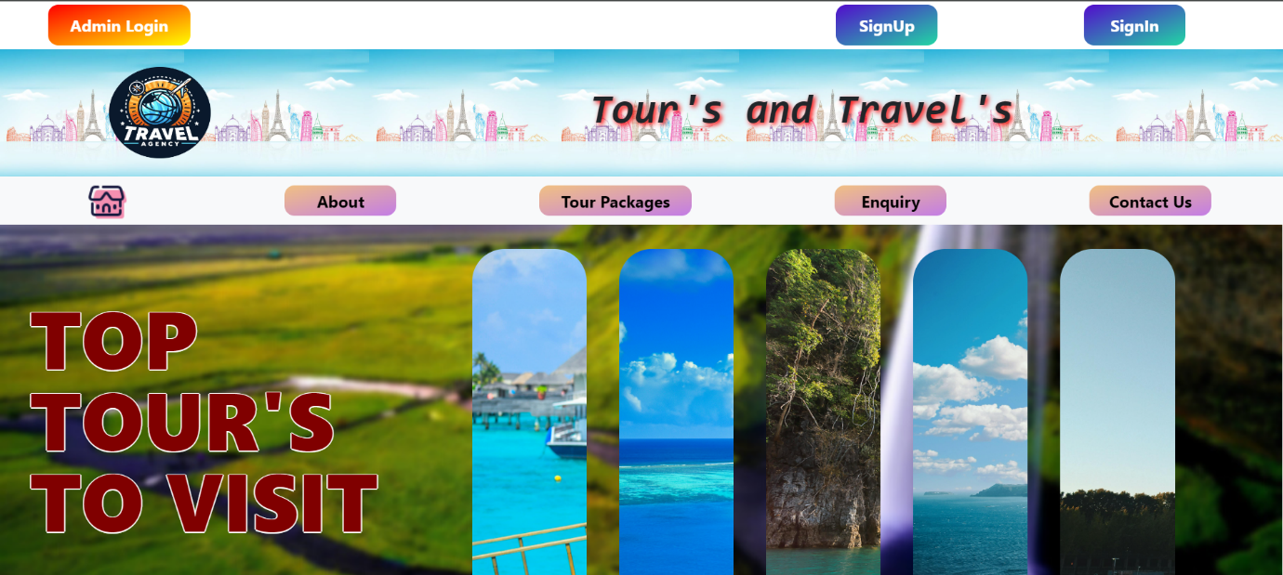
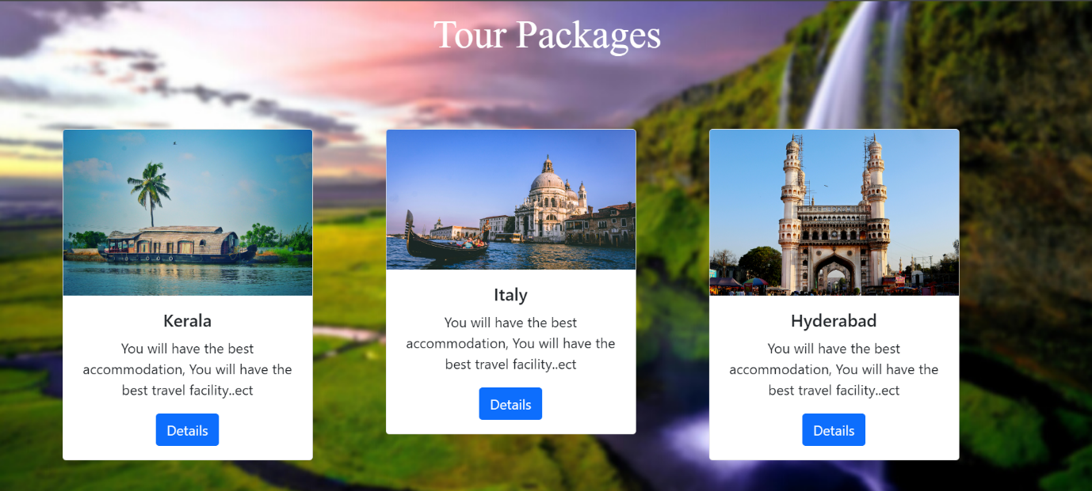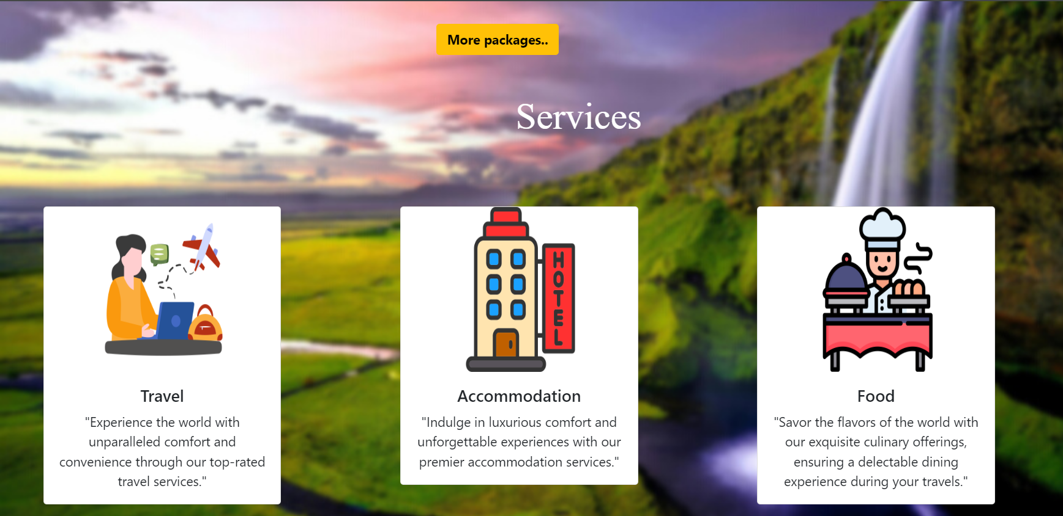
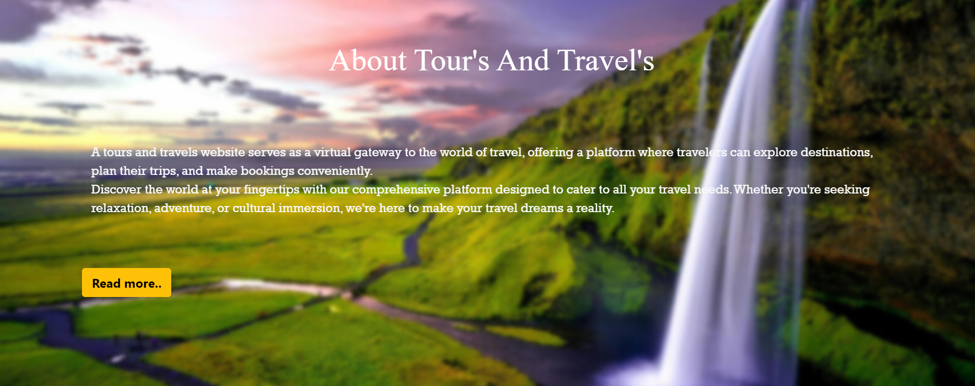
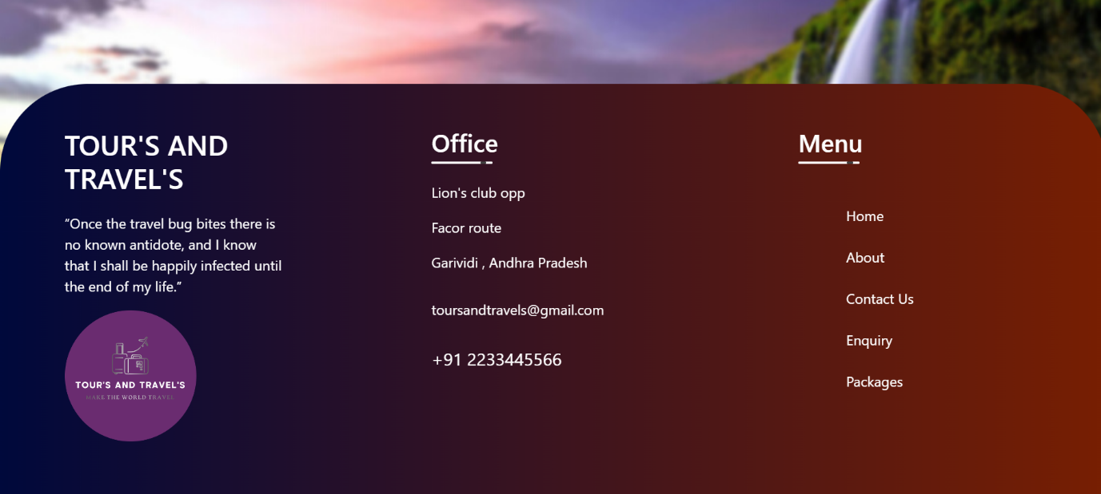

About:
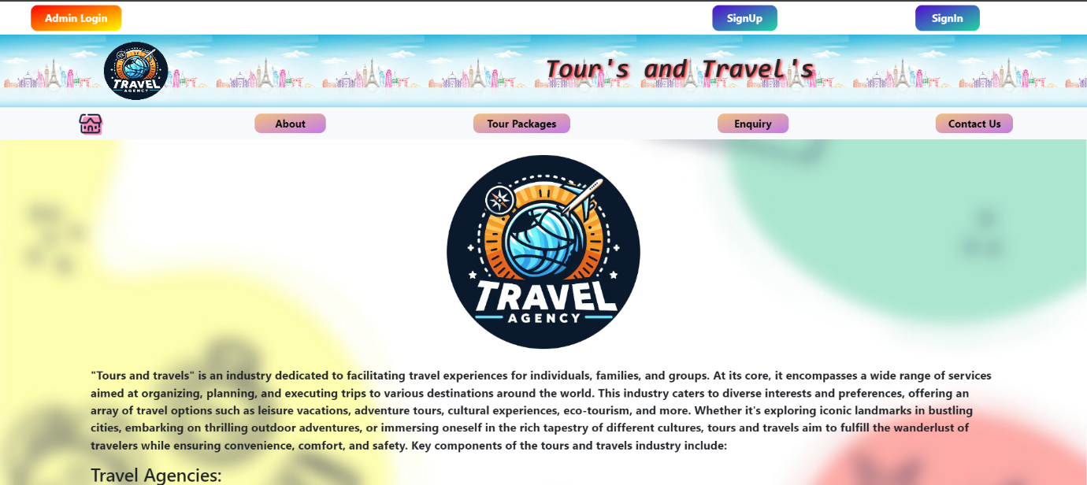

Tour packages:
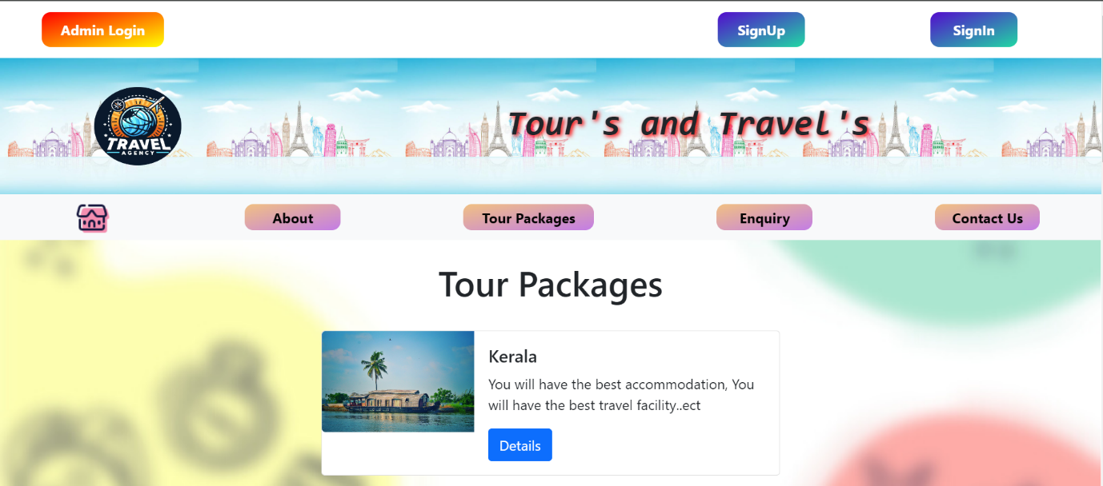
Enquiry:
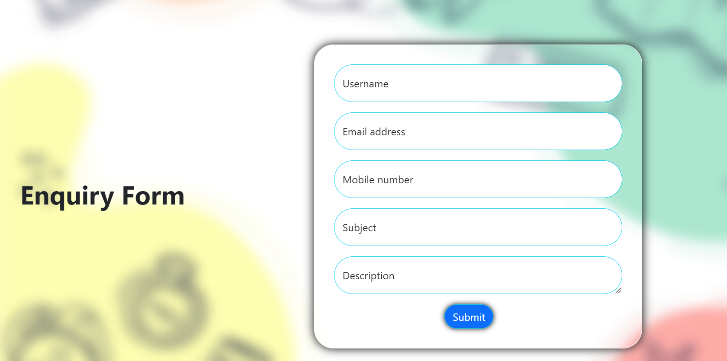

Contact us:
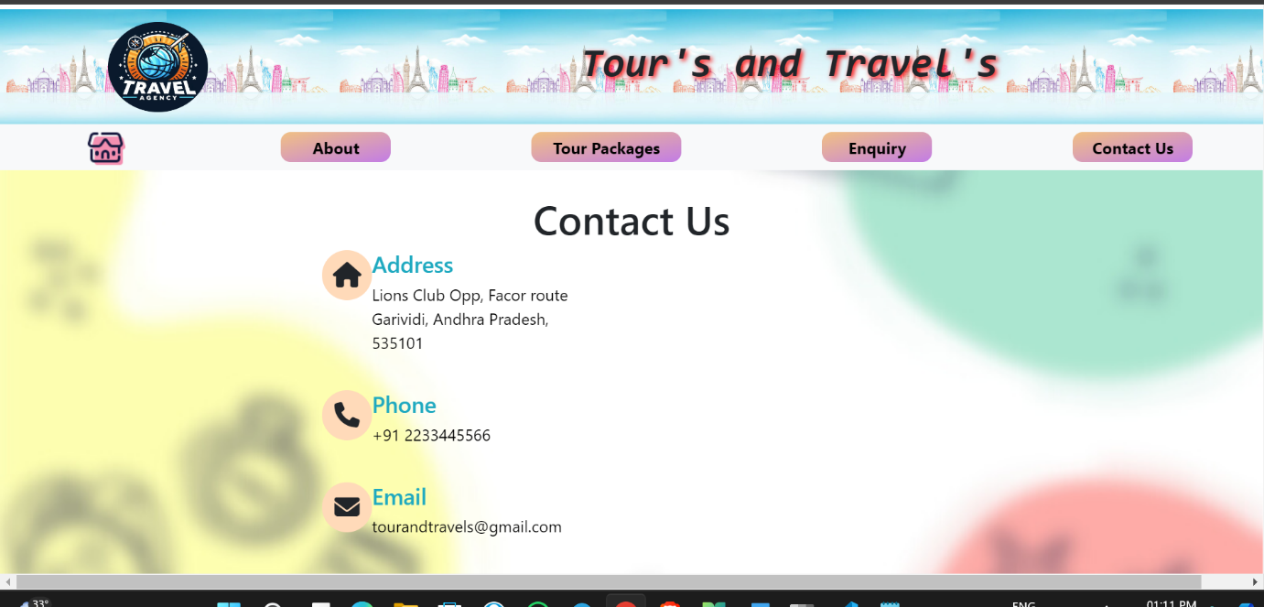
Admin login:
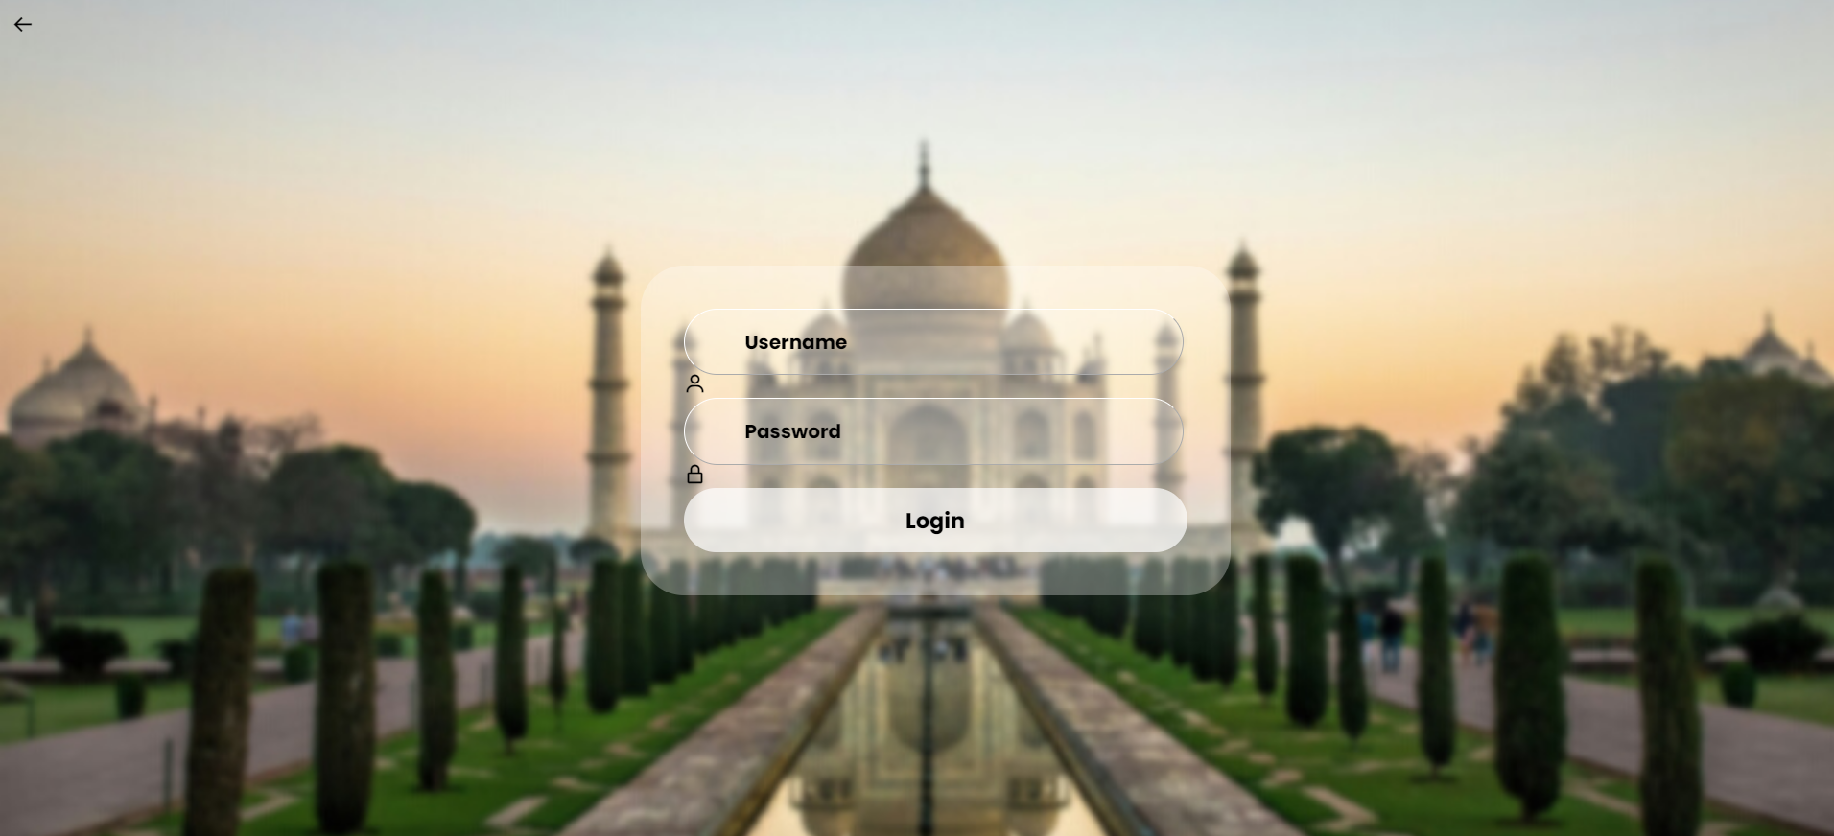
Admin dashboard:
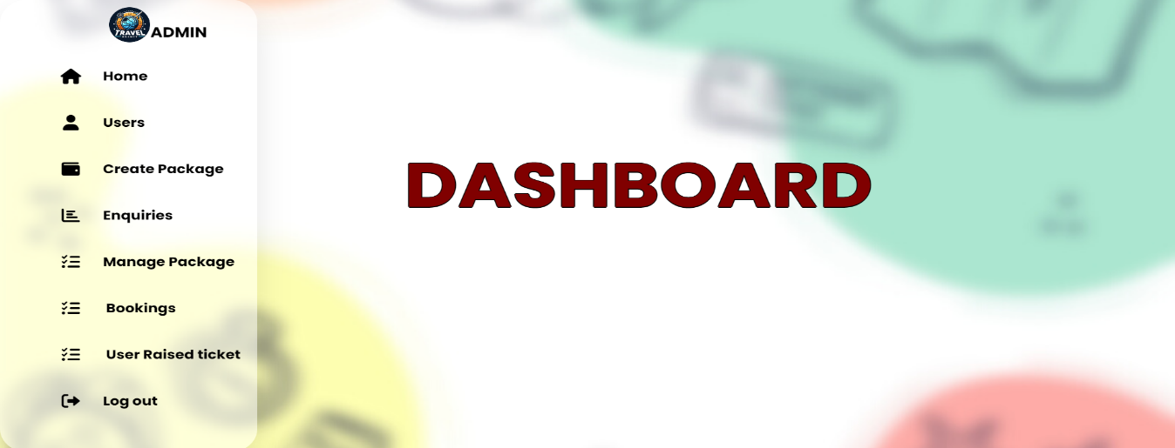
Users:
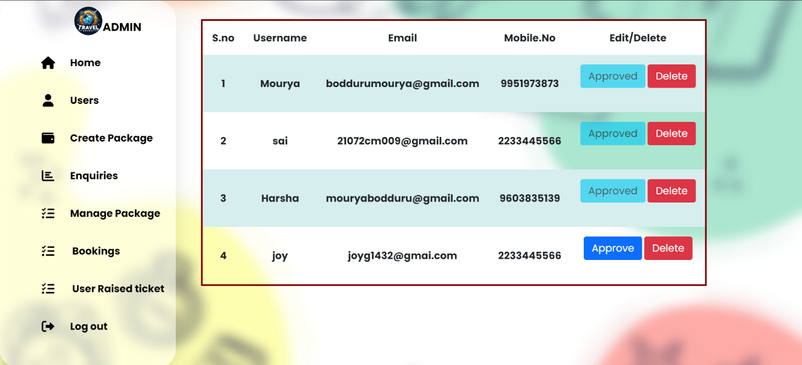

Create package:
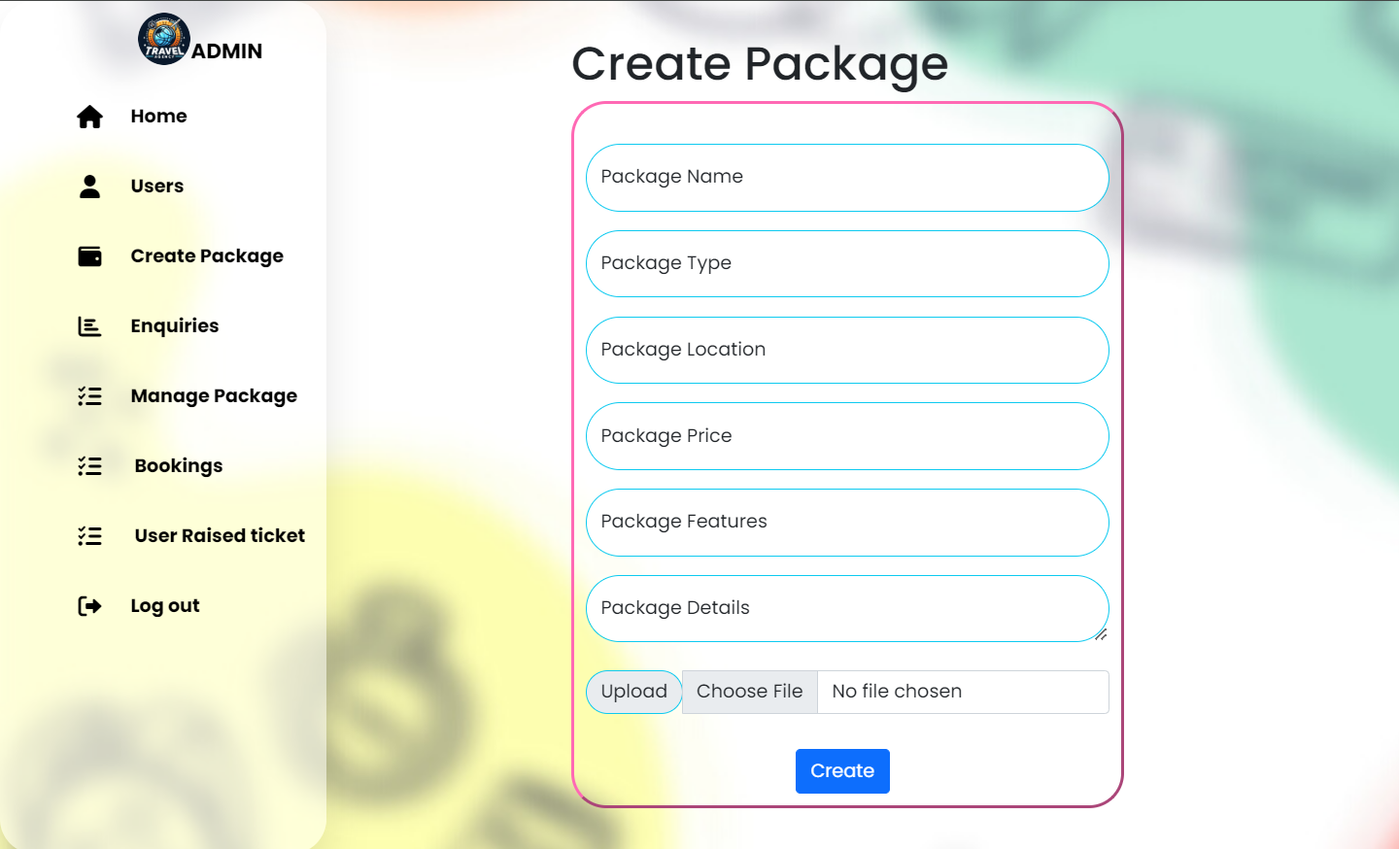

Enquiries:
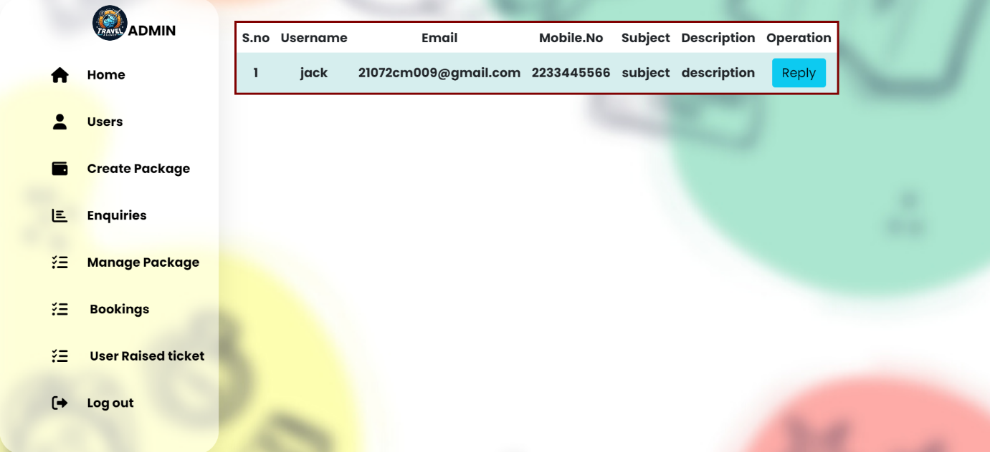
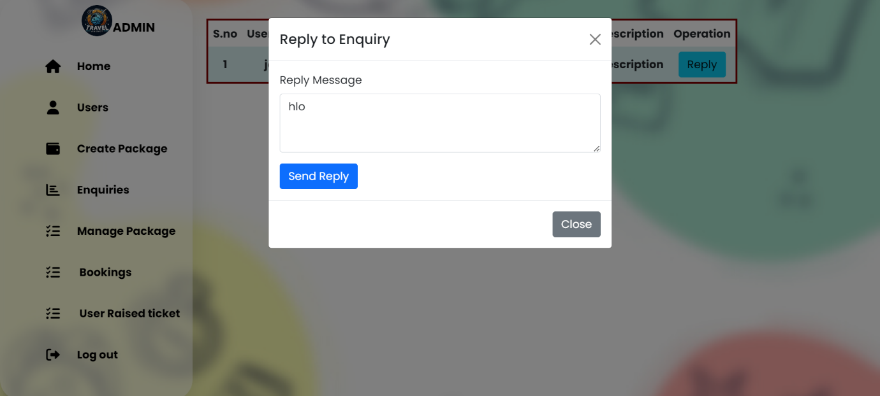
Manage packages:
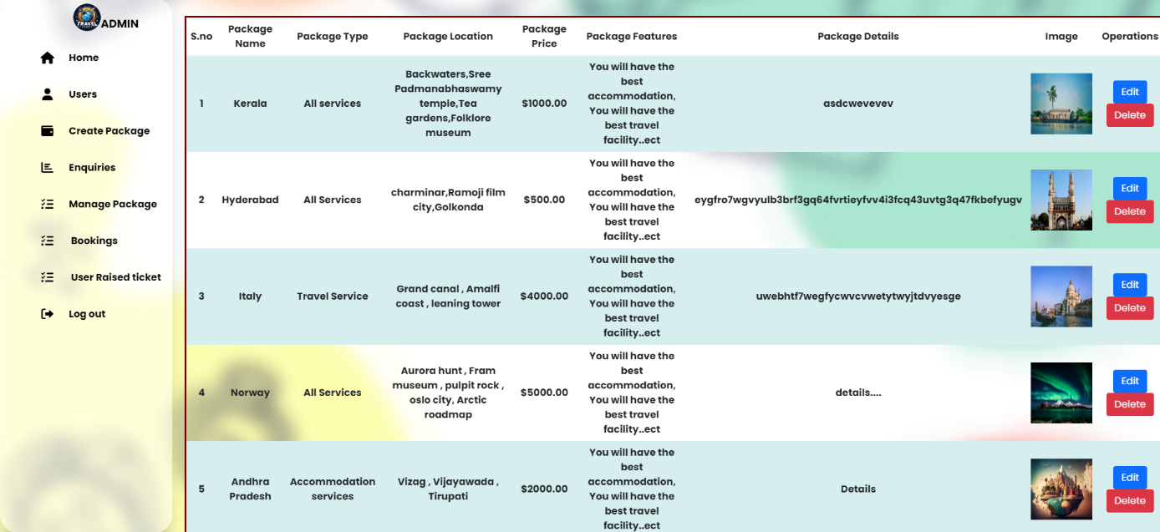
Bookings:
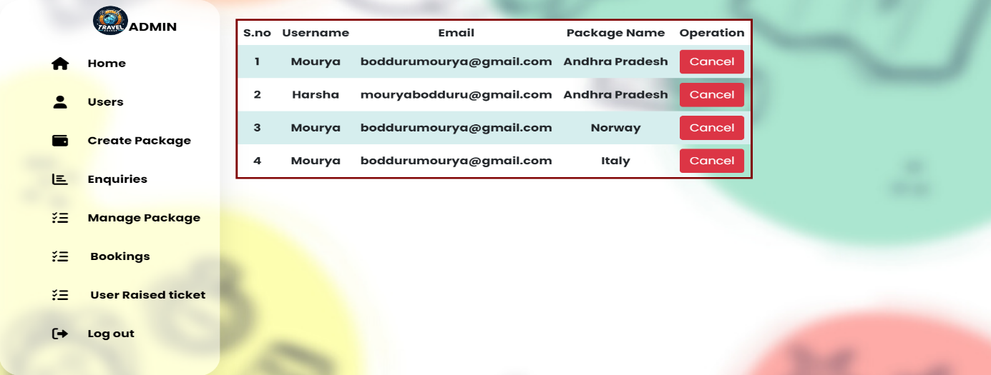
User raised tickets:
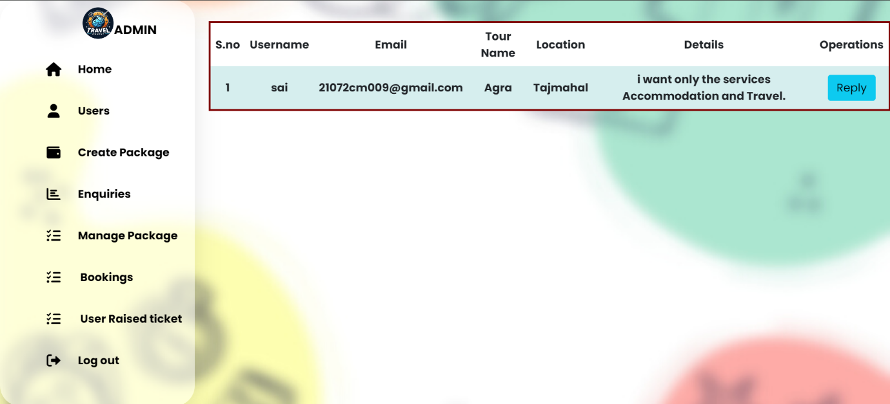
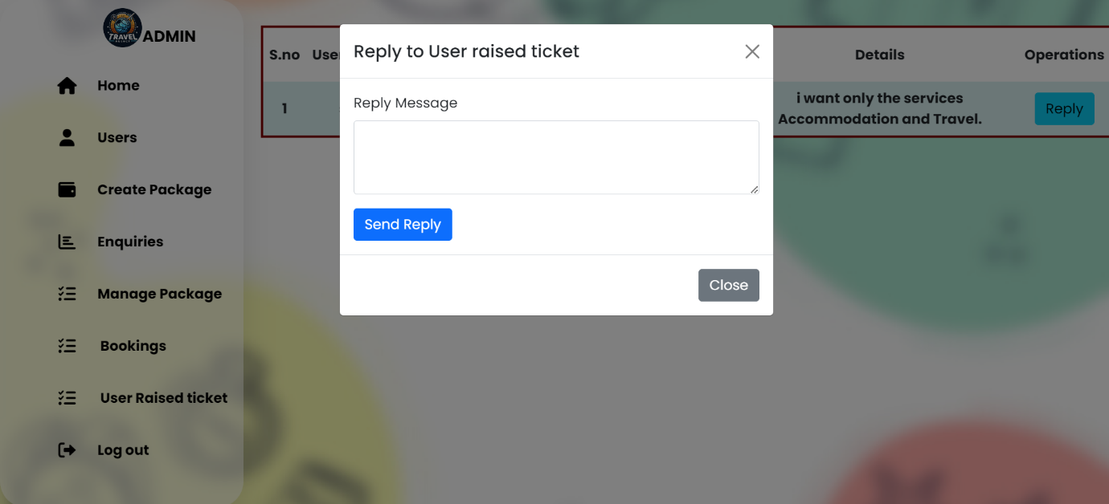

User registration:
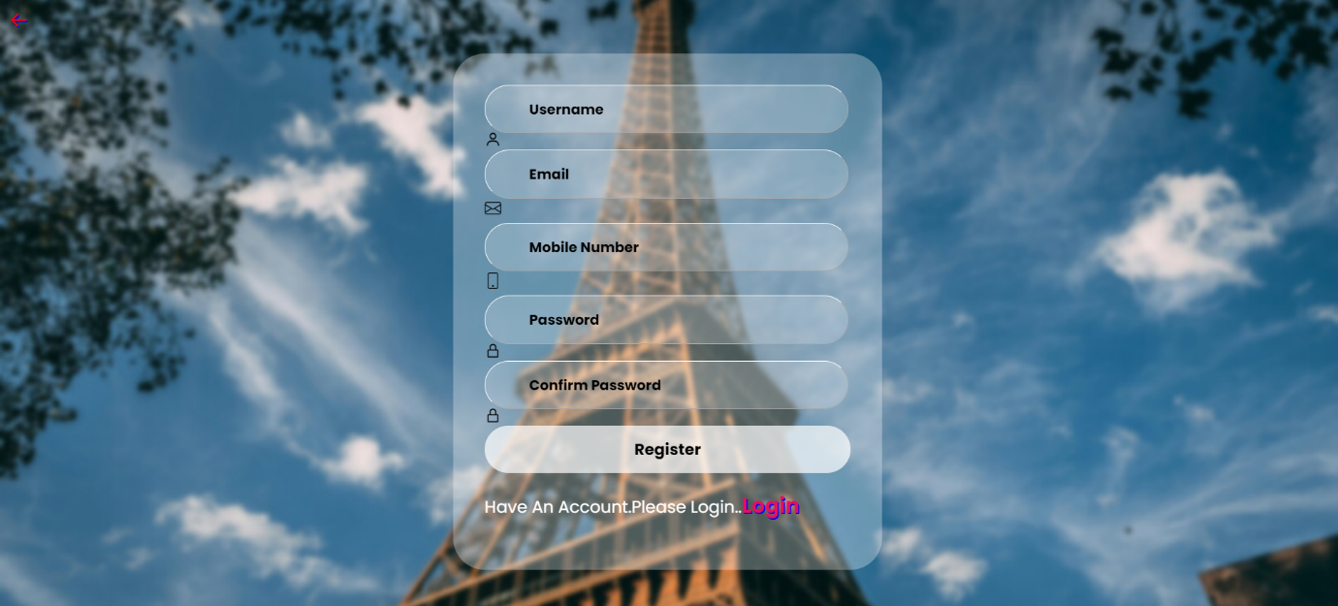
User login:
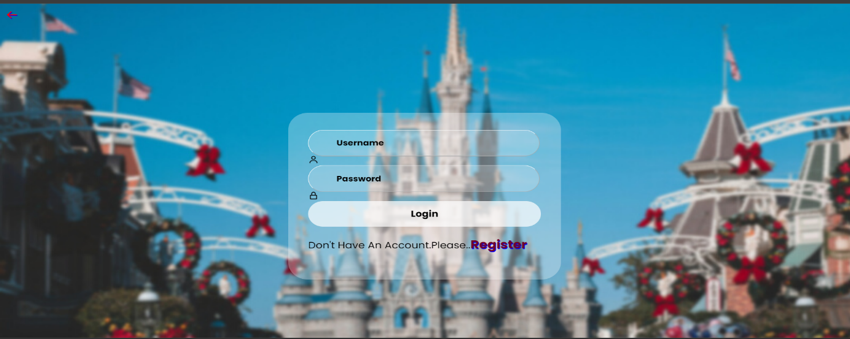
User dashboard:
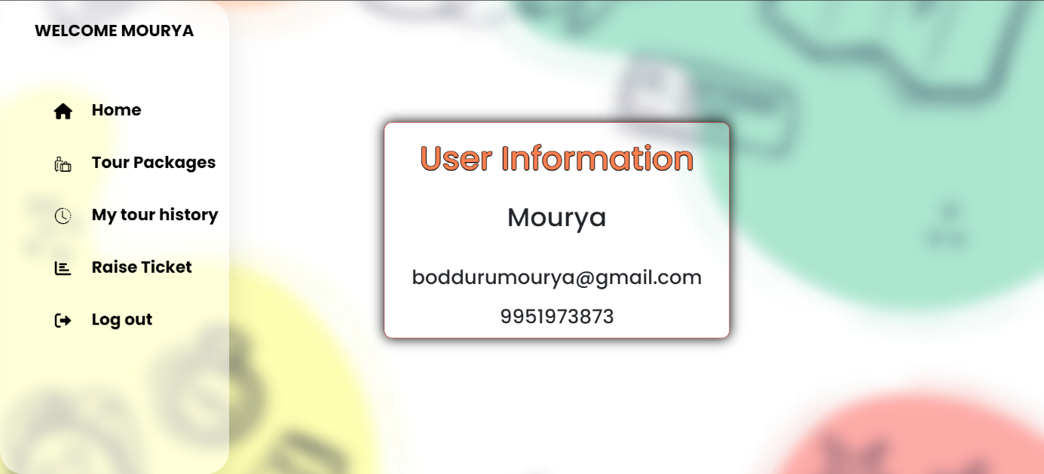
Tour packages:
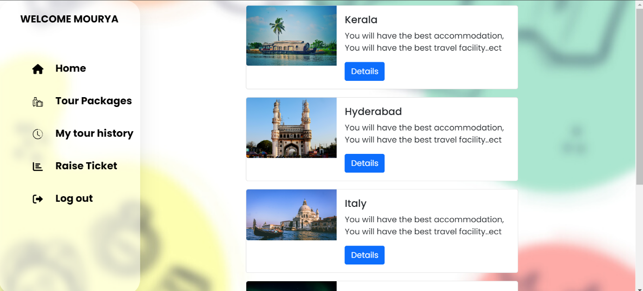
Details:
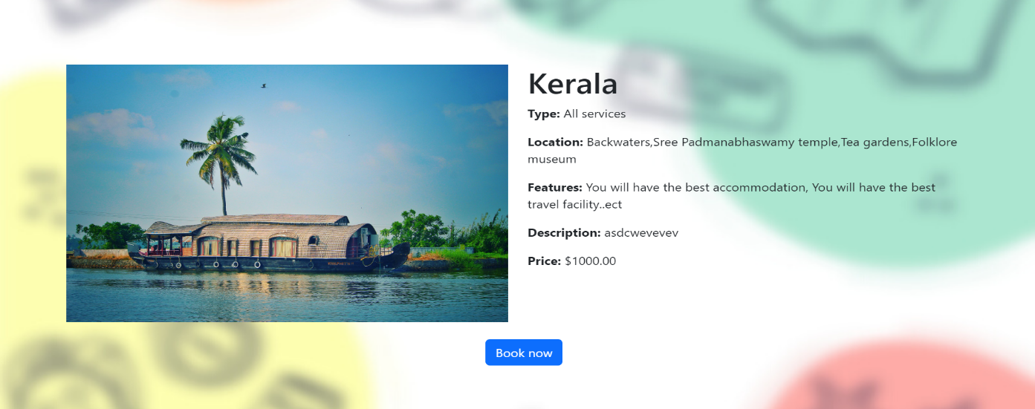
Thank you:
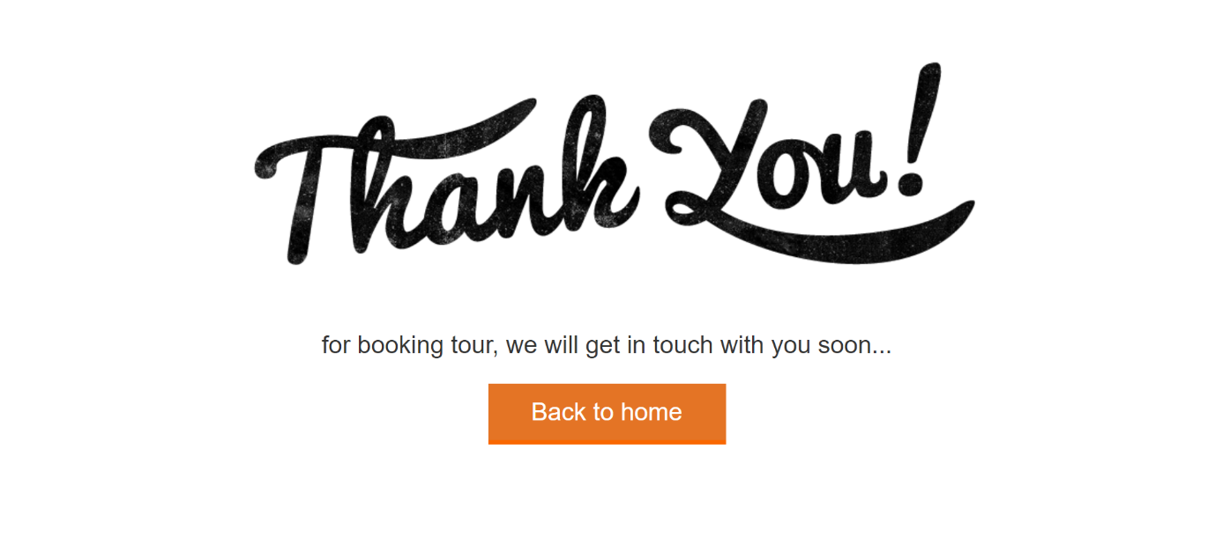
My tour history:
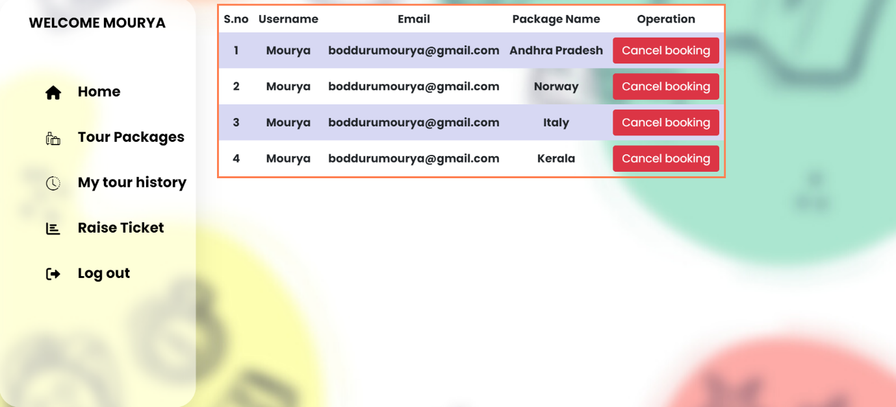
Raise ticket:
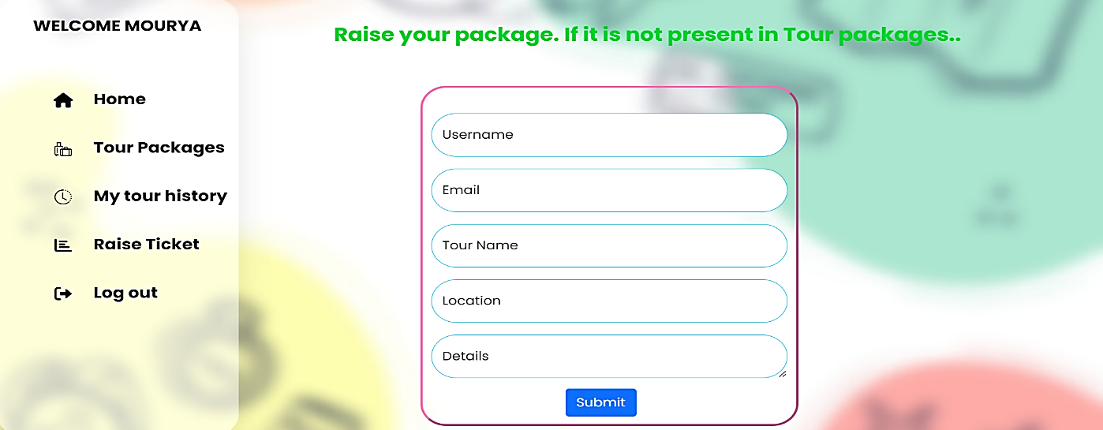

BIBLIOGRAPHY
Introduction:
TMS, short for Tourism Management System, represents a cutting-edge software solution aimed at revolutionizing and modernizing traditional tourism operations.
Objective:
The primary objective of the TMS project is to overcome challenges and constraints associated with conventional tourism systems by introducing a comprehensive digital platform.
Automation Focus:
TMS places a strong emphasis on automation, optimizing critical processes like trip planning, booking management, and customer interactions to enhance operational efficiency.
Digital Transition:
The project envisions a shift from manual, paper-based methods to a secure and efficient digital alternative, leveraging modern technologies for superior outcomes.
Technological Foundation:
TMS is constructed on a robust technological foundation, utilizing HTML, CSS, Bootstrap, JavaScript, Ajax for the front end, and Python with the Django Framework for the back end.
Database Management:
To ensure robust data storage and retrieval, Django database is selected, guaranteeing data integrity and scalability.
Development Environment:
Supported by Microsoft Windows 11, the development environment utilizes essential tools like Visual Studio Code for coding and Django database administration for database management.
User-Friendly Interface:
TMS features a user-friendly interface tailored to travel agents and tourists alike, offering intuitive search functions and seamless online booking experiences.
Comprehensive Documentation:
The project documentation provides a comprehensive overview of TMS, covering architecture, functionalities, system requirements, and the advantages it brings to travel agencies and tourists.

References
- Chat GPT

https://chatgpt.com

- W3 Schools

https://w3schools.com
- PHP Gurukul – Retrieved Project Idea

https://phpgurukul.com

- Stack overflow – Retrieved from

https://stackoverflow.com
- Sketch Board - Retrieved from

https://sketchboard.com

